
Jolly Helmet
Make your Helmet Happy Again!
Clean it. Dry it.
Wear it happy.
Coin-operated helmet cleaning and drying stations
MEJES, JERAHMEEL ALZEL M.
CRUZ, DEAN RYAN P.
MENDOZA, RICAH S.
MARTOS, KRISTINA E.
DEVELOPERS AND DESIGNERS
USER MANUAL - TECHNICIAN GUIDE

Jolly Helmet User Manual
Technician guide
Revision 11, 4 November 2026. Made by MEJEZ STUDIO.
This book is one of three: Customer guide, Admin guide, Technician guide (with the Reference). The full manual, with everything in one file, is JollyHelmet_UserManual_v11.pdf.
Two PDFs come with this book. The plain file (single pages in reading order): print double-sided, flip on the LONG edge, Letter size (A4 at 'fit'). The file whose name ends in _BOOKLET (two pages on each landscape sheet, the last page next to the first): print double-sided, flip on the SHORT edge, 100 percent (actual size), then fold the whole stack in half and staple on the fold. Every chapter starts on a right-hand page; the page count is a multiple of 4 so the booklet folds cleanly.
Questions or faults: MEJEZ STUDIO, 0975 791 5832.

Contents
Technician guide (Hardware, online monitoring and maintenance) 5
How it is built 6
Component list 9
Pinouts 11
Circuit and wiring 15
Firmware and flashing 20
Online monitoring 22
Maintenance 30
Hardware troubleshooting 32
Reference (Safety, charts, settings and index) 33
Safety and emergencies 34
Box flowcharts 37
Troubleshooting decision trees 40
Settings reference 48
Circuit schematics 52
Glossary 58
Version and revisions 62
Index 65

Technician guide (Hardware, online monitoring and maintenance)
Components, pinouts, wiring, firmware, online monitoring and maintenance

How it is built
Each machine is a small team of ESP32 boards that talk by radio (ESP-NOW, channel 1). The only wires between the boards are power wires.
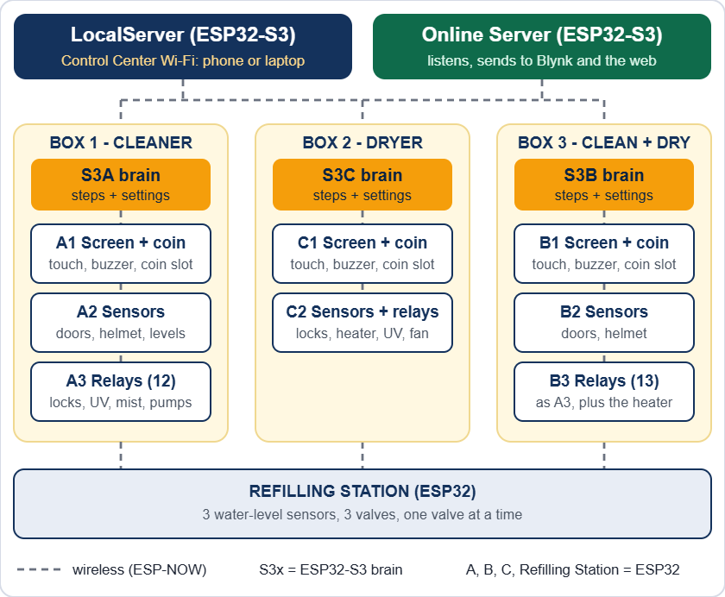
The whole installation: three boxes, the Refilling Station, the LocalServer and the Online Server

The 14 boards

Board | Where | What it does (sketch folder)
S3A | Box 1 | Main controller (brain). Runs every step and keeps the settings. (ESP32_S3A)
A1 | Box 1 | Touch screen, coin slot, buzzer. (ESP32_A1)
A2 | Box 1 | Sensors: 4 doors, helmet, 2 containers, 2 water sensors. (ESP32_A2)
A3 | Box 1 | 12 relays: 4 locks, 3 humidifiers, 2 UV, coin power (2 channels spare). (ESP32_A3)
S3C | Box 2 | Main controller. (ESP32_S3C)
C1 | Box 2 | Touch screen, coin slot, buzzer. (ESP32_C1)
C2 | Box 2 | 3 door sensors, helmet sensor and 6 relays: 3 locks, heater, UV, fan. (ESP32_C2)
S3B | Box 3 | Main controller. Runs the 36-step flow and reads the Refilling Station. (ESP32_S3B)
B1 | Box 3 | Touch screen, coin slot, buzzer. Shows OUT OF ORDER by itself and beeps when S3B is silent. (ESP32_B1)
B2 | Box 3 | Sensors: the helmet ultrasonic and the four door switches only. (ESP32_B2)
B3 | Box 3 | 13 relays (11 used: 4 locks, 3 humidifiers, 2 UV, coin power, heater; the 2 spare channels are never driven). All off after 15 s without S3B; releases a trapped helmet. (ESP32_B3)
Refilling Station | Boxes 1 to 3 (Box 3 only for now) | Built for 3 water-level sensors and 3 valves. For now it watches and fills the container of Box 3 only (WATCH_BOX); with more boxes switched on it fills one at a time. (ESP32_REFILL)
LocalServer | Control Center | Wi-Fi JollyHelmet-Local, settings pages, revenue. Also broadcasts its revenue totals for the Online Server. (ESP32_LOCALSRV)
Online Server | Online | Listens to the machines and sends a snapshot to Blynk for the web page. Never controls anything. (ESP32_ONLINESRV)

Brains and terminals
- Brains (S3A, S3B, S3C, LocalServer, Online Server) are ESP32-S3 boards with 16 MB flash and 8 MB PSRAM. Nothing is wired to them except power.
- Terminals (the A, B, C boards and the Refilling Station) are plain ESP32 (WROOM) boards on screw-terminal expansion boards. They hold every sensor, relay and display wire. A3 and B3 must not be WROVER (PSRAM) boards, because GPIO 16 and 17 are relays.
- Settings are saved inside the brains (S3A, S3B, S3C) and the Refilling Station. The LocalServer only saves the revenue numbers. The Online Server saves its own Wi-Fi, Blynk token and the daily revenue history.
- If a terminal hears nothing from its brain for 15 seconds, it switches its relays off (heater, UV, mist, coin power). If a helmet is stuck behind a closed door, it also lets the enclosure lock go.
- Box 3 never traps a helmet. If the main controller S3B is silent, the relay controller B3 releases the enclosure lock when the sensors B2 see a helmet inside with the door shut, and the screen board B1 shows OUT OF ORDER with "Your helmet is still inside" and beeps. If S3B is alive but B2 or B3 is silent, S3B does the same. After a power cut, when S3B restarts, it hands a helmet that is still shut inside back first (OPEN B).
- UPS for Box 3: put B1, B2, B3 and the supply of the enclosure lock on a UPS, and leave the S3 boards, the LocalServer and the Online Server on mains. A power cut then silences the S3 and Box 3 goes OUT OF ORDER from any step, so the customer can take the helmet out. A paid session cut by the power is not restored.
- One number decides "helmet inside" for S3B, B3 and B1: Helmet counts as inside under (Box 3 page, default 15 cm). B3 and B1 learn it from S3B and keep it in their own memory.
- There is no mechanical release on the enclosure door. With no power at all (the UPS empty) the lock stays shut until the power is back, so size the UPS for the longest power cut you expect.

Component list
Quantities are for the whole installation: Box 1, Box 2, Box 3 and the Refilling Station.

Boards and display

Item | Qty | Used in
ESP32 DevKit (ESP32-WROOM-32) with screw-terminal expansion board | 9 | A1 A2 A3 B1 B2 B3 C1 C2 Refilling Station
ESP32-S3 DevKit N16R8 (16 MB flash, 8 MB OPI PSRAM) | 5 | S3A S3B S3C LocalServer Online Server
2.8 in SPI TFT with resistive touch (ST7789, 240 x 320) | 3 | A1, B1, C1
Allan multi-coin acceptor, 12 V | 3 | One per box
Active buzzer | 3 | A1, B1, C1
Resistor 10 kΩ | 3 | Coin signal lines

Sensors

Item | Qty | Used in
MC-38 magnetic door sensor (reed) | 11 | Box 1: 4, Box 2: 3, Box 3: 4
Ultrasonic distance sensor HC-SR04 (5 V) | 5 | Helmet: 3 (one per box). Main containers: 2 (Box 1 only; Box 3's are not used any more).
Analog water-level sensor | 5 | Box 1: 2, Refilling Station: 3 (one in each box's main container)

Relay boards

Item | Qty | Used in
16-channel relay board, active-LOW | 2 | A3 (12 used), B3 (13 used)
6-channel relay module | 1 | C2 (all 6 used)
Relay module, 3 channels or more, active-LOW | 1 | Refilling Station (3 used)

Loads

Item | Qty | Used in
12 V solenoid door lock | 11 | Box 1: 4 (enclosure, panel, back, side). Box 2: 3. Box 3: 4.
Humidifier (mist maker), 5 V | 6 | Box 1: 3, Box 3: 3
Solenoid valve, normally closed | 3 | Refilling Station: one per box (coil voltage still to be decided: 12 V DC or 220 V AC)
UV-C germicidal disinfection lamp, 220 V | 5 | Box 1: 2, Box 2: 1, Box 3: 2
Heater (hair dryer), 220 V | 2 | Box 2, Box 3
Fan, 5 V | 1 | Box 2 cool-down

Power and protection

Item | Qty | Used in
12 V power supply | 5 | Locks, coin slots and the DC-DC modules
DC-DC power module, 12 V in, 3.3 V and 5 V out (multi output) | 5 | All ESP32 boards, screens, relay boards, sensors, mist makers
Diode 1N4007 | 11 or more | One across every lock solenoid
Fuses, 220 V inlet or outlets, earth | - | Mains side: UV-C lamps and heaters

Not electrical: the main containers (one per box), one water supply (a tank or a tap) for the Refilling Station, tubing and fittings.

What is in each unit

Item | Box 1 | Box 2 | Box 3 | Refilling Station
ESP32 terminal boards | 3 | 2 | 3 | 1
ESP32-S3 main controller | 1 | 1 | 1 | -
Touch screen, coin slot, buzzer | 1 | 1 | 1 | -
Door sensors | 4 | 3 | 4 | -
Ultrasonic sensors | 3 | 1 | 1 | -
Water-level sensors | 2 | - | - | 3
Door locks | 4 | 3 | 4 | -
Humidifiers | 3 | - | 3 | -
Valves | - | - | - | 3
UV-C lamps (220 V) | 2 | 1 | 2 | -
Heater | - | 1 | 1 | -
Fan | - | 1 | - | -

Pinouts
GPIO numbers are the ESP32 pin names (D4 = GPIO4). Every relay input is active-LOW: the pin goes LOW to switch the relay ON. These tables match the flashed firmware and the pin sheet RevisedJollyHelmet_Checked.xlsx.

Relay input numbers (IN1, IN2...) come from the Cirkit drawing. The GPIO is what the firmware drives. If a relay sits on a different input, trust the GPIO and fix the label.

S3A, S3B, S3C and LocalServer - nothing to wire
These four boards have no external wiring: power (5 V) and the USB cable for flashing only. GPIO 35, 36 and 37 are used inside the module by the OPI PSRAM: never connect anything to them.

A1, B1, C1 - screen, coin slot, buzzer
Identical wiring on A1, B1 and C1, with one difference: the coin signal of C1 is on GPIO 32 (A1 and B1 use GPIO 23).

GPIO | Signal | Wired to
15 | TFT CS | Display CS
4 | TFT RESET | Display RST
2 | TFT DC | Display DC (RS)
13 | MOSI (shared) | Display SDI (SDA) and touch T_DIN
14 | SCK (shared) | Display SCK (SCL) and touch T_CLK
27 | Touch CS | Touch T_CS
12 | Touch MISO | Touch T_DO
23 (C1: 32) | Coin signal | Allan COIN, through a 10 kΩ resistor
21 | Buzzer | Active buzzer +
5V | Display power | Display VCC and LED (BLK)
GND | Ground | Display, coin acceptor, buzzer -

- Not connected: display SDO (MISO), touch T_IRQ, coin COUNTER.
- Coin acceptor 12 V: from the COIN POWER relay on A3 and B3 (Box 1, Box 3). Straight from the 12 V supply in Box 2.
- Free pins on A1 and B1: 5, 16, 17, 18, 19, 22, 25, 26, 32, 33. Free pins on C1: 5, 16, 17, 18, 19, 22, 23, 25, 26, 33.

A2 (Box 1) and B2 (Box 3) - sensors

GPIO | Signal | Wired to
26 | Helmet ultrasonic TRIG | Sensor TRIG
25 | Helmet ultrasonic ECHO | Sensor ECHO
32 | Alcohol container TRIG | Sensor TRIG
33 | Alcohol container ECHO | Sensor ECHO
23 | Scented container TRIG | Sensor TRIG
22 | Scented container ECHO | Sensor ECHO
27 | Enclosure door | MC-38 sensor S
14 | Panel door | MC-38 sensor S
19 | Back door | MC-38 sensor S
18 | Side door | MC-38 sensor S
34 | Alcohol water sensor | SIG (analog, input only)
35 | Scented water sensor | SIG (analog, input only)

- Ultrasonic VCC 5 V. Water sensors 3.3 V. Door sensors: the other wire goes to GND, the ESP32 supplies the pull-up (closed = LOW).
- Free pins: 2, 4, 12, 13, 15, 16, 21.
- B2 (Box 3) reads only the helmet ultrasonic (GPIO 26 and 25) and the four door switches (27, 14, 19, 18; the last one is the Side door). The container ultrasonics (32, 33, 23, 22) and the two water sensors (34, 35) are not read by the B2 firmware: the Refilling Station reads the containers. On A2 they belong to the earlier Box 1 program and the Box 3 flow does not use them.

A3 - Box 1 relays (16-channel board)

GPIO | Input | Load | Supply
4 | IN1 | Enclosure door lock | 12 V
16 | IN2 | Panel door lock | 12 V
17 | IN3 | Back door lock | 12 V
23 | IN4 | Side-door lock | 12 V
18 | IN5 | Humidifier 1 | 5 V
19 | IN6 | Humidifier 2 | 5 V
25 | IN7 | Humidifier 3 | 5 V
22 | IN9 | Coin power (the coin slot's 12 V) | 12 V
27 | IN10 | UV-C lamp 1 | 220 V
21 | IN11 | UV-C lamp 2 | 220 V
33 | IN12 | Spare (not used) | -
32 | IN13 | Spare (not used) | -

- Supply column: what each load runs on. The UV-C lamps are 220 V: the relay contact switches the live wire (see Switching 220 V loads). Locks and the coin slot are 12 V, humidifiers 5 V.
- IN8 and IN14 to IN16 are not used. GPIO 2, 12 and 15 are left idle (boot pins).

B3 - Box 3 relays (16-channel board)
Pin for pin the same as A3, plus one more relay:
Box 3 notes: the two spare channels (GPIO 33 and 32) are never driven by the B3 firmware, whatever S3B or a dashboard asks. The lock on GPIO 23 is the SIDE LOCK (the lock of the side door).

GPIO | Input | Load | Supply
26 | IN14 | Heater (hair dryer) | 220 V via the relay contacts

C2 - Box 2 sensors and relays

GPIO | Signal | Wired to
26 | Helmet ultrasonic TRIG | Sensor TRIG
25 | Helmet ultrasonic ECHO | Sensor ECHO
27 | Enclosure door | MC-38 sensor S
14 | Panel door | MC-38 sensor S
19 | Back door | MC-38 sensor S

Relays (6-channel module):

GPIO | Input | Load | Supply
4 | IN1 | Enclosure door lock | 12 V
16 | IN2 | Panel door lock | 12 V
17 | IN3 | Back door lock | 12 V
18 | IN4 | Heater (hair dryer) | 220 V
23 | IN5 | Fan | 5 V
5 | IN6 | UV-C lamp | 220 V

- GPIO5 gives a short pulse when the board powers up, so the UV relay may click once. Recommended: when you next reflash C2, move the UV relay to a boot-safe pin (13, 21, 22, 32 or 33) so a 220 V UV-C lamp can never flash at power-up.

Refilling Station - sensors and valves
One plain ESP32 (WROOM) on a screw-terminal expansion board, plus a relay module with 3 channels used. The pins are in the pin sheet RevisedJollyHelmet_Checked.xlsx (block F1) and in ESP32_REFILL.ino.

GPIO | Signal | Wired to
34 | Water-level sensor, Box 1 container | SIG (analog, input only)
35 | Water-level sensor, Box 2 container | SIG (analog, input only)
32 | Water-level sensor, Box 3 container | SIG (analog)
21 | Valve 1 (Box 1) | Relay module IN1
19 | Valve 2 (Box 2) | Relay module IN2
18 | Valve 3 (Box 3) | Relay module IN3
3V3, GND | Sensor power | VCC and GND of the three sensors
5V, GND | Relay module power | VCC and GND of the relay module

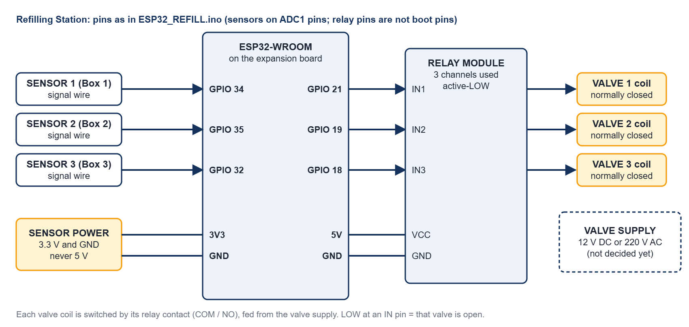
Refilling Station: sensors to the ADC1 pins, relay inputs to GPIO 21, 19 and 18, valve coils switched by the relay contacts
- The sensors are on ADC1 pins (GPIO 32 to 39) because ADC2 cannot be read while Wi-Fi or ESP-NOW runs. Power the sensors from 3.3 V: the ADC input must never see 5 V.
- The relay modules of this project are active-LOW (LOW at an input = relay on = valve open). The firmware assumes that (VALVE_ACTIVE_LOW 1); if the module you fit is active-HIGH, set it to 0.
- First power-up with the valves unplugged: the three relay LEDs must be OFF. The serial banner says which level the sketch assumes. Then use Test valve one valve at a time.
- The valve coil voltage (12 V DC or 220 V AC) is not decided yet. No flyback diode was asked for (the station stands apart from the boxes and has no coin signal). If the station resets when a valve switches, put a diode across a DC coil or an RC snubber across an AC coil.
- The relay pins are not strapping pins (0, 2, 5, 12, 15) and not flash pins, and stay quiet at power-up. The valves are driven closed before the pins become outputs.
- Which boxes the station serves is set by WATCH_BOX in ESP32_REFILL.ino. It is { false, false, true } for now: only Box 3 is read and refilled, and Box 1 and Box 2 are reported as NOT WATCHED (REFILL_OFF, 254). To switch a box on, set its entry to true and reflash the station.

Circuit and wiring

Circuit summary
- Every box is a group of ESP32 boards and the Refilling Station is one board. They share only power and the radio channel.
- Every lock, lamp, mist maker and heater is switched by a relay contact. Every sensor is read directly by a terminal board.
- Voltages: 12 V (door locks, coin slots), 5 V (ESP32 boards, screens, relay boards, HC-SR04 ultrasonic sensors, humidifiers), 3.3 V (water-level sensors, from the ESP32 3V3 pin or the DC-DC module), 220 V (the UV-C lamps and the heaters).

Power and grounding
- Measure every output of the DC-DC module (5 V and 3.3 V) with a meter before you connect boards. Never put 12 V on an ESP32 pin or on the 5 V rail.
- Join all grounds: 12 V -, 5 V - and every ESP32 GND. Never join a 12 V + to a 5 V +.
- A relay module has a JD-VCC jumper. Jumper on: the coils run from the module's VCC (one 5 V supply, shared ground). Jumper off: feed JD-VCC and its GND from a separate 5 V supply.
- Locks and heaters starting can pull the 5 V down. Symptoms: white screen, LocalServer restarts, odd resets. Cures: short thick 5 V wires, a 470 to 1000 µF capacitor next to the TFT and the ESP32, a separate 5 V for the relay coils. The firmware also switches relays on 25 ms apart.
- Put a fuse on every supply. Keep the 220 V wiring in its own enclosure, away from the boards.
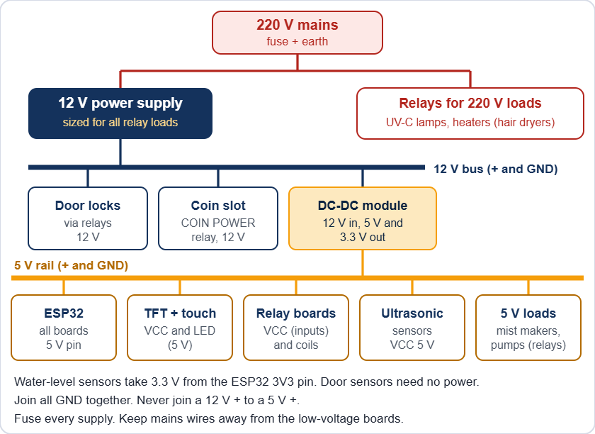
Power for one box (the exact rails are listed in the component tables)

Relay outputs
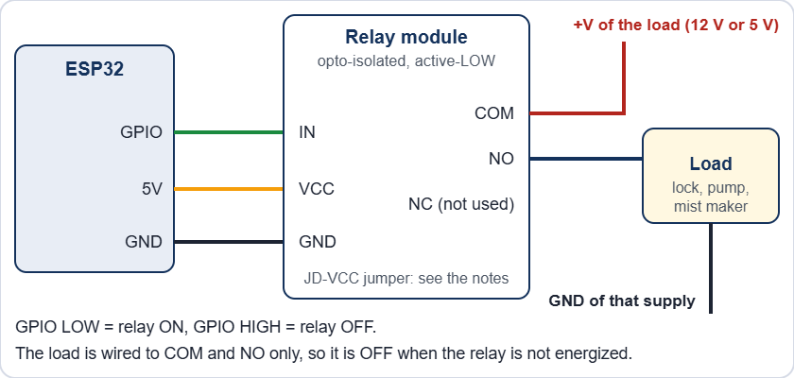
One relay channel
- Wire the load to COM and NO. Then it stays off when the relay or the board has no power. Leave unused channels unwired.
- Relay pins avoid GPIO 0, 1, 2, 3, 5, 12, 14, 15 because they pulse at boot. Safe output pins: 4, 13, 16 to 19, 21 to 23, 25 to 27, 32, 33.
- GPIO 34, 35, 36 and 39 are input only.

Switching 220 V loads (UV-C lamps and heaters)
- The UV-C germicidal lamps and the heaters (hair dryers) run on 220 V. The relay contact switches only the live wire. The neutral goes straight from the supply to the load. The relay board's low-voltage side (IN pins, VCC) stays on the ESP32 side.
- Use relay contacts rated for the load. Most relay boards are 10 A at 250 V AC. A hair dryer can draw 8 A or more (read its label). A UV-C lamp draws much less, but its ballast or driver can pull a high current at switch-on.
- Fuse the 220 V feed of each box. Connect the earth wire to every metal part. Use insulated terminal blocks, strain relief on every cable, and keep 220 V wires away from the low-voltage boards and the screen.
- Recommended: a door switch in series with the live wire of each UV-C lamp, so the lamp cannot be lit with a door open even if the firmware or a relay fails.

Never open a box with the 220 V connected. Unplug it first.

Door locks
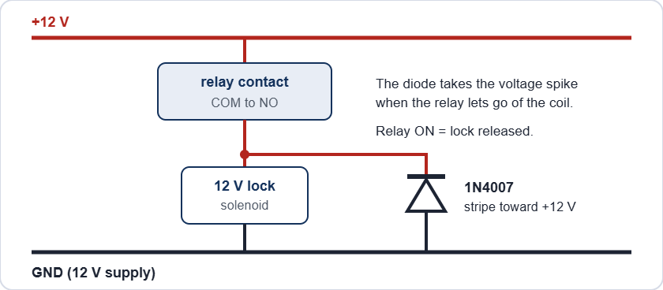
A door lock with its flyback diode
The locks are power-to-unlock: the relay is ON only while the door may open (the OPEN steps, Maintenance, or the trapped-helmet release). With no power a solenoid keeps its door locked. The 1N4007 takes the voltage spike when the relay lets go of the coil. Without it the spike can reset the board and burn the relay contacts.

After a power cut the solenoid locks stay shut until the power is back. The UPS on B1, B2, B3 and the lock supply keeps Box 3 able to release a trapped helmet. When power is back, release a lock from the Control Center: Box page, Maintenance, ENCLOSURE LOCK. It switches itself off after 60 seconds.

Coin slot and buzzer
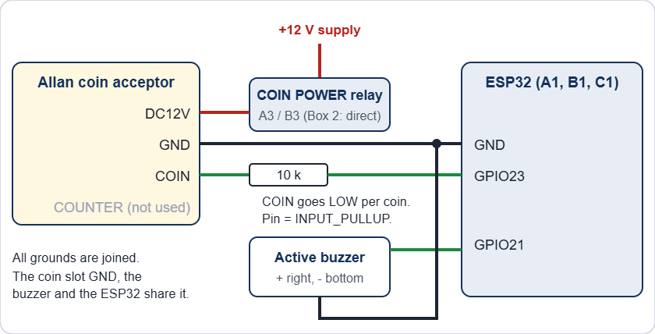
Coin acceptor and buzzer on A1, B1 and C1
- The Allan COIN output pulls to ground once per coin pulse. The pin is INPUT_PULLUP and the firmware counts falling edges, so the pin never sees more than 3.3 V. Check it once with a meter on every new unit.
- One coin is many pulses (a 20-peso coin is 20 pulses over 1 to 2 seconds) and B1 reports its pulse count to S3B once a second. When the required coins are reached, S3B (Box 3) therefore keeps counting until no new pulse has been seen for 1.5 seconds (at most 6 seconds) and only then moves on: every coin counted becomes time and revenue, up to the most coins (default 90).
- FAST, MED, SLOW and SET are switches on the acceptor itself, not wires. COUNTER is not used.
- The buzzer is the active type: GPIO21 HIGH = sound. If it sounds weak, or the board resets when it sounds, drive it through a transistor.

Sensors

Sensor | Wire | Goes to
Ultrasonic HC-SR04 | VCC | 5 V
 | TRIG | GPIO (output)
 | ECHO | GPIO (input), through a divider (the HC-SR04 gives 5 V)
 | GND | GND
Water-level | SIG | GPIO34 or GPIO35 (analog, input only)
 | VCC | 3.3 V
 | GND | GND
MC-38 door | S | GPIO (INPUT_PULLUP). Magnet near = closed = LOW
 | GND | GND

The HC-SR04 sends 5 V on ECHO and the ESP32 pins are not 5 V tolerant. Put a divider on every ECHO: ECHO to 1 kΩ to the GPIO, and 2 kΩ from that GPIO to GND. (A 3.3 V module such as the HC-SR04P needs none.) The pin sheet shows no divider, so check that every sensor has one.

Screen and touch
The display and the touch controller share the SPI lines MOSI (13) and SCK (14). Each has its own chip select (15 and 27). TFT_eSPI drives the display as an ST7789, 240 x 320. B1 is mounted upside down, so it runs setRotation(3).

Mains and UV safety

Mains can kill. The UV-C lamps and the heaters are on 220 V. Unplug the machine and wait before you open a box. Keep all 220 V wiring fused, earthed, in a closed enclosure with strain relief, away from the low-voltage boards.

UV-C light injures eyes and skin, even for a moment. Never look at a lit lamp and never test it with the door open. The firmware switches UV and mist off the moment a door opens, but firmware is not a safety device. Recommended: a door switch in series with the lamp's live wire, so the lamp cannot be on with a door open, and a warning label on every box.

Firmware and flashing

Arduino IDE settings

Board type | Settings
Terminals (A, B, C, Refilling Station) | Board: ESP32 Dev Module. esp32 core 3.3.7. Upload speed 921600. Other options default.
Brains (S3A, S3B, S3C), LocalServer and Online Server | Board: ESP32S3 Dev Module. USB CDC On Boot: Enabled. CPU 240 MHz. Flash mode QIO 80 MHz. Flash size 16 MB. Partition: 16M Flash (3MB APP/9.9MB FATFS). PSRAM: OPI PSRAM. Upload speed 921600.

Libraries
- TFT_eSPI 2.5.43: only A1, B1, C1 (edit its User_Setup.h, see below).
- ArduinoJson 7.4.3, Async TCP 3.5.0, ESP Async WebServer 3.12.0: only the LocalServer and the Online Server.
- Everything else (WiFi, ESP-NOW, Preferences) comes with the ESP32 core.

TFT_eSPI User_Setup.h

Setting | Value
Driver | ST7789_DRIVER (the only one not commented out)
TFT_WIDTH, TFT_HEIGHT | 240, 320
TFT_MISO, TFT_MOSI, TFT_SCLK | 12, 13, 14
TFT_CS, TFT_DC, TFT_RST | 15, 2, 4
TOUCH_CS | 27
SPI_FREQUENCY, SPI_TOUCH_FREQUENCY | 20000000, 1000000

Flash a new or replacement board
- Find the board in the table The 14 boards and open its sketch folder in the Arduino IDE.
- The folder must hold the same Shared_Common.h as ESP32_S3A (the master copy). Different copies make boards ignore each other's messages.
- Choose the settings above, plug in the USB cable and upload.
- Open the Serial Monitor at 115200 baud to read the board's log.
- Watch the board's badge turn ONLINE in the Devices list on the Control Center Dashboard.
- For a brain (S3) or the Refilling Station, enter its settings again on its Control Center page. A new board starts with the default values.

Never run a bench or settings sketch (ESP32_S3A_CONFIG_BENCH, ESP32_S3C_CONFIG_BENCH, ESP32_REFILL_FAKE (the stand-in station), ESP32_A1_WIDGET_TEST) at the same time as the LocalServer or the real brain. They send the same messages and fight over them.

Test sketches

Sketch | Use
ESP32_A3_BENCH_TEST | Tests A3 alone: it pretends to be S3A and A2.
ESP32_B3_RELAY_TEST | Wi-Fi page (BOX 3 B3 TEST, password 12345678) to switch each B3 relay by hand.
ESP32_BUZZER_ULTRASOUND_TEST | Wi-Fi page to test a buzzer and read an ultrasonic sensor.
ESP32_C1_CALIBRATE | Touch calibration: touch the 4 targets, copy the printed calData line into the terminal sketch.

Safety built into the firmware
- Every relay pin is set OFF before it becomes an output, so relays do not pulse at power-up.
- Relays that turn on are staggered 25 ms apart, so loads do not start in the same instant.
- A door that opens during a run switches UV and mist off at once (SAFETY PAUSE).
- A terminal that loses its brain for 15 seconds switches its relays off.
- Hand-set relays in Maintenance switch themselves off after 2 seconds (the box does it by itself; the coin power is exempt, and the tick box Bypass Safety 2 Seconds Relay turns it off). With the bypass the heater still goes off after 5 minutes and the enclosure lock after 60 seconds.
- Box 3 never locks a helmet in: with a helmet shut inside, OUT OF ORDER and power cuts release the enclosure lock and the screen board beeps (see How it is built, Brains and terminals).
- The coin slot only has power while a payment is possible (Box 1 and Box 3).

The LocalServer must be flashed with the version that broadcasts its revenue totals every 10 seconds, or the Online Server shows no analytics. No other board needs a reflash for the Online Server.

Online monitoring
The Online Server is one more ESP32-S3 board. It listens to the machines (it never controls them), sends a snapshot to Blynk every minute, and a web page shows that snapshot from any phone or PC. Nothing on the web page can start, stop or change a machine.
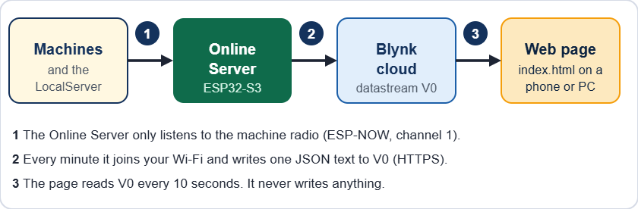
From the machines to the web page

What you need
- The Online Server (ESP32_ONLINESRV), powered with 5 V, near the machines so it hears every board by radio.
- The LocalServer switched on and flashed with the new version. It sends the revenue totals. Without it the analytics stay empty (the live data still works).
- A 2.4 GHz Wi-Fi network with internet: the school Wi-Fi or a phone hotspot, on any channel.
- A Blynk account and the Blynk Console (blynk.cloud).
- The folder ONLINE_WEB (the web page): put it on any web host, or just open index.html from a PC.

Step 1 - Set up Blynk (once)
- Sign in to the Blynk Console. Open Developer Zone, then My Templates, then New Template.
- Name: Jolly Helmet Online Server. Hardware: ESP32. Connection type: Wi-Fi. Click Done.
- Open the Datastreams tab. Click New Datastream, then Virtual Pin. Fill in V0 as in the table below and click Create.
- Optional: make V1 to V4 the same way (single numbers for Blynk's own dashboard and phone app). Default value 0.
- Optional: open the Events tab, click New Event, code alert (exactly), type Warning or Critical, and switch on a notification (push or e-mail).
- Click Save at the top right of the template. Without Save the device does not see the new datastreams.
- Open Devices, click New Device, choose From template, pick your template, name it Online Server and click Create.
- Open the device, tab Device info, and copy the Auth Token. Keep it private.

Name | Pin | Type | Min | Max | Needed?
live | V0 | String | - | - | Yes. The web page reads only this one.
revenue | V1 | Double | 0 | 100000000 | Optional (2 decimals)
customers | V2 | Integer | 0 | 10000000 | Optional
alerts | V3 | Integer | 0 | 30 | Optional
running | V4 | Integer | 0 | 3 | Optional

Step 2 - Set up the Online Server
- Flash ESP32_ONLINESRV (same settings as the LocalServer, see Firmware and flashing) and power it.
- On a phone, join the Wi-Fi JollyHelmet-Online (password 12345678). The setup page opens by itself. If it does not, open http://192.168.4.1. It looks like a router page: the menu button (three bars, top left) opens Network Map, Internet, Blynk and More settings.
- Open Internet. Tap Search for networks and tap your Wi-Fi, or type its name (Network name). Type its password (Show lets you check it).
- Open Blynk and paste the Blynk device Auth Token. The Public status device token is optional (see Customer status page below).
- Open More settings. Choose how often to send (1 minute is a good start), the time zone (8 for the Philippines) and, if you want the quota line on the web page, the number of Blynk messages your plan gives per month. Tick "single numbers V1 to V4" and "Blynk event" only if you made them in Blynk.
- Tap Save and connect. The board tests the Wi-Fi and Blynk at once. The setup page may stop answering for a few seconds: this is normal, the board moves to your router's channel. It reconnects by itself and Network Map shows the result.
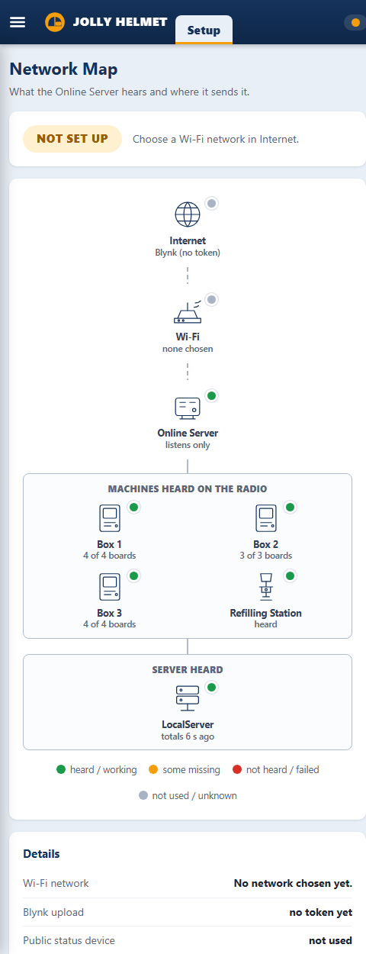 | 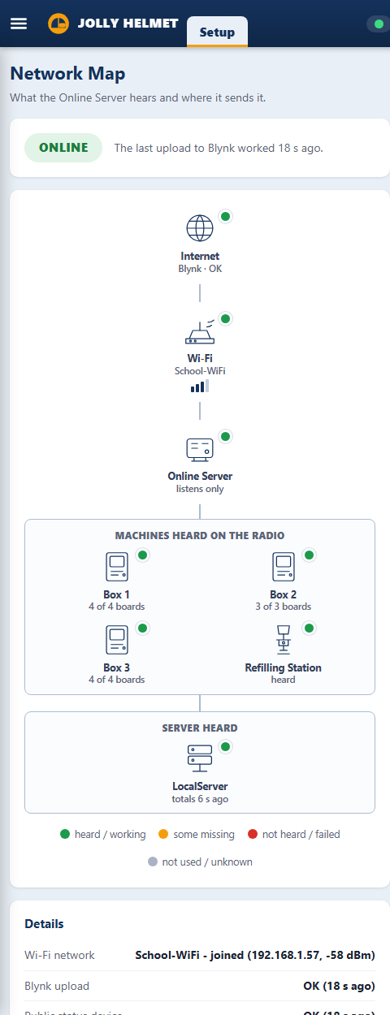 | 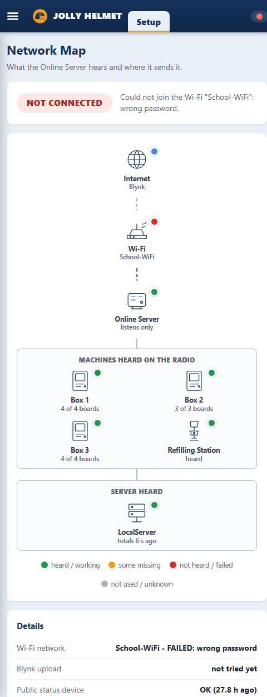
The Network Map of the setup page: not set up yet, online, not connected (wrong password)

On the Network Map | Meaning
ONLINE (green) | The last upload to Blynk worked. It shows how many seconds ago.
NOT SET UP (amber) | No Wi-Fi or no token is saved yet.
TESTING (blue) | The board is joining the Wi-Fi and talking to Blynk.
NOT CONNECTED (red) | The Wi-Fi or Blynk failed. The reason is written under the badge.
Machines heard | Under "Machines heard on the radio": Box 1 4 of 4 boards, Box 2 3 of 3, Box 3 4 of 4 and the Refilling Station heard, 12 boards in all. A box that misses a board is red and says OUT OF ORDER (it cannot be used).
LocalServer (totals) | Under "Server heard": the LocalServer says "totals 6 s ago" when it is on. "Not heard yet": switch it on or reflash it.
Clock | Set at the first successful upload. The day charts and the secure connection need it.

While you use the setup page the board waits 90 seconds before its next upload, so the page does not drop while you type. A phone left connected to its Wi-Fi is disconnected for a moment at every upload.

Step 3 - Open the web page
- Put the folder ONLINE_WEB on a web host (GitHub Pages, Netlify, Cloudflare Pages, the school server) or open index.html on a PC.
- The first time, the page asks for the Blynk Auth Token. Paste it and click Connect. It is kept in that browser only. On a phone you can also open the page once as index.html#token=THE_TOKEN.
- To try the page without hardware, add ?demo to the address (or ?demo=alerts to see the warnings).
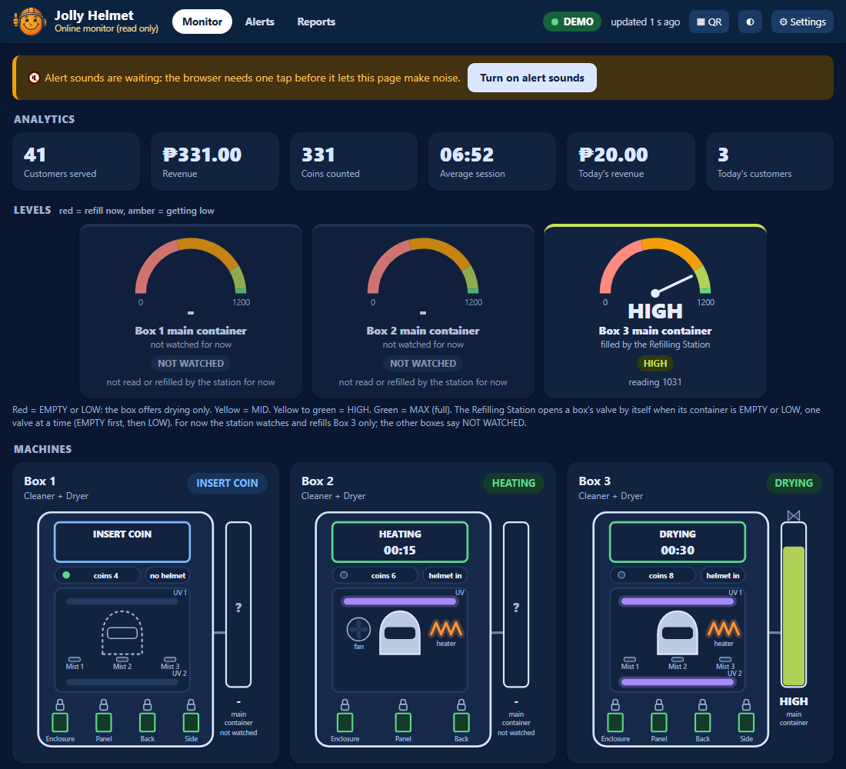 | 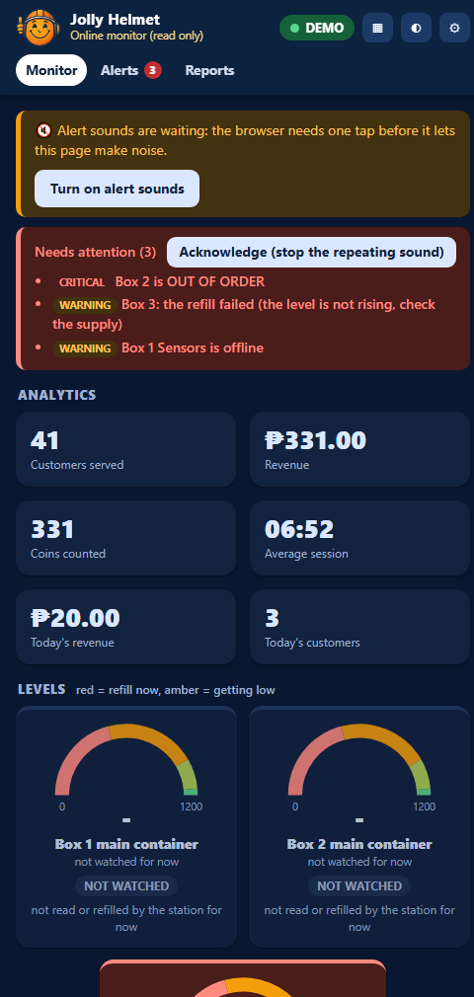
The web page on a PC and, on the right, on a phone with warnings (demo data)

Reading the web page

Part | What it shows
Badge (top right) | LIVE green: fresh data. DELAYED amber: a little late. OLD DATA red: nothing new for a long time. BAD TOKEN or NO LINK: the page cannot read Blynk. Next to it: "updated 5 s ago".
Needs attention (red box) | A box out of order, the Refilling Station offline, a failed refill, a sensor fault, a board that is not heard, or a container getting low (early warning).
Analytics | Customers served, revenue, coins counted, average session, today's revenue and customers.
Levels | One dial for the main container of each box, read by the Refilling Station: red = EMPTY or LOW, yellow = MID, yellow-green = HIGH, green = MAX. A valve symbol lights while the station fills that container. A box the station does not watch (Box 1 and Box 2 for now) shows a grey NOT WATCHED dial.
Machines | A card for Box 1, Box 2 and Box 3: the step (green = running, blue = a customer is using it, amber = needs attention, red = out of order), time left, coins, helmet in or not, the UV lamps, mist makers, heater and fan that are on, the door locks and the level of the main container.
Last 14 days, Last cycles | Revenue per day (today on the right) and the last 10 sessions (revenue and length).
Network map | Blynk, the Wi-Fi with its signal, the Online Server and the boards it hears on the radio for each box, the Refilling Station and the LocalServer. Green = working, red = not heard. A box that misses any one of its boards cannot be used: it turns red and says OUT OF ORDER, with the missing boards listed.
Online Server details | How long it has run, why it last restarted, the Wi-Fi signal at the site, free memory and the Blynk messages used this month.
Buttons | QR: the QR code and the sign for the customer page. The half-moon switches light and dark. Settings: token, Blynk server and refresh time (5 seconds to 1 minute).

If a box shows "sensor board offline", the page does not hear that board, so it hides that box's doors and helmet instead of showing wrong numbers.

Good to know
- The page only reads. A Blynk token can also write values, so do not publish it: leave it out of the page files and type it in the page.
- Blynk counts messages. One upload a minute is about 43,200 a month, plus one for V1 to V4 and one per alert event. Check your plan's limit.
- The Blynk Console may show the device as offline. This is normal: the board uses Blynk's web API, not a permanent connection. The page decides "alive" from the numbers inside the data.
- The board hears the machines on radio channel 1 and leaves it for about 5 to 10 seconds at every upload, so do not send faster than every 30 seconds.
- Only 2.4 GHz Wi-Fi works (the ESP32 cannot join 5 GHz).

Online troubleshooting

Message | Meaning | What to do
Requested datastream doesn't exist in the product | The template has no V0. | Create V0 (String) in the template and Save it.
Invalid token, BAD TOKEN | The token is wrong or belongs to another device. | Copy it again from Device info.
read Timeout, no answer | Blynk did not answer. The board tries once more with a shorter message. | Check that the Wi-Fi really has internet. Try your regional Blynk server in More settings. The status says if only the SHORT version went through.
network not found, wrong password | The Wi-Fi cannot be joined. | Check the name and password. It must be 2.4 GHz.
the clock could not be set | The Wi-Fi blocks the time servers (NTP). | Allow internet access. Last resort: tick "Skip the TLS certificate check".
Machines heard stays low after an upload | The radio did not return to channel 1. | Switch the Online Server off and on, and tell the builder.
Revenue totals not heard | The LocalServer is off or has the old version. | Switch it on, or reflash it.
V1-V4 failed, event failed | The optional datastreams or the alert event are missing in the template. | Create them, or untick them in the setup page.
The page says OLD DATA | The uploads stopped. | Open the board's setup page and read its status.

Customer status page (a second Blynk device)
The customer page (status.html) shows Box 1, Box 2 and Box 3 as FREE, IN USE or OUT OF ORDER. It is public, so it must not use your private token (a Blynk token can also write). It reads a second Blynk device that holds nothing but those three boxes.
- In the Blynk Console open Devices, New Device, From template, and pick the same template as before. Name it Jolly Helmet Public status.
- Open it, tab Device info, and copy its Auth Token. This token may be public. Never use the private token here.
- Open the Online Server setup page (Wi-Fi JollyHelmet-Online). Paste the token into Public status device token and tap Save and connect. The row Public status device on top then says OK.
- In the folder ONLINE_WEB open js/config.js and write the token in publicToken. (If you leave it empty, the QR code carries the token in the address.) Edit the prices and the "Something wrong?" line in the same file.
- Put the folder on the web host. Open the online page and tap the QR button. Paste the public token if it asks. Tap Print the sign and stick it on every machine.
- Test it: scan the QR code with a phone. The boxes must show FREE or IN USE. status.html?demo shows made-up data.

The public device holds | Meaning
b | For Box 1, Box 2 and Box 3: the step number, the seconds left and whether the brain is heard. Nothing else.
seq, ts, iv | A counter, the time and the upload interval. The page shows NO INFORMATION when the data is older than about 4 minutes.

If somebody misuses the public token, the worst they can do is write a wrong status into that one device (the next upload overwrites it within a minute) and use up some Blynk messages. They cannot reach the private device, the revenue or the machines. The page costs one more Blynk message per upload.

Online Server firmware of 2026-10-10
Flash ESP32_ONLINESRV again (same settings, see Firmware and flashing). The new version:
- counts every finished session per box, per hour of the day and per weekday, from the brains' own counters, and keeps the counts inside the board (this feeds Busiest hours, Busiest days and What each box earns in the Reports tab);
- writes the public status device when its token is set;
- shows two new rows on its setup page: Public status device and Sessions counted, and has a button Reset the per-box and busiest-hours statistics under More settings.
Until it is flashed, the three charts above say "Needs the Online Server firmware of 2026-10-10". Everything else works with the old firmware.

Optional customer names (Blynk V5)
A customer can type a nickname (12 characters at most) on the card of the machine that is running his or her cycle. Everybody who opens the customer page sees it ("Maria's helmet"), the customer's own phone says the helmet is done at the end, and the name clears by itself when the cycle ends. It is optional: no name, nothing shown.
- One extra datastream, once: in the Blynk Console, open the template of the public device, Datastreams, New, Virtual Pin V5, name names, data type String. Without it the page works as before and a customer who tries to add a name is told that names are not switched on yet.
- A name can be added only after the coins are in, so a payment that is cancelled never leaves a name behind. The phone that typed it can edit or remove it; other phones can only see it.
- The name is shown only while the box is looking after a helmet (OPEN A to ABORT) and only for that cycle. Flash the Online Server firmware of 2026-10-14 or later so it adds each box's session counter to the public value.
- Whatever sits in V5 is treated as untrusted text: the page strips < and > and control characters and shows it only as plain text. The page tells the customer to use a nickname, because the name is public to everybody who opens the page.
- Cost: a few Blynk messages for each customer who adds a name, nothing for the others. In js/config.js, names: false hides the feature and namesPin chooses the datastream.

Alerts when the page is closed (Blynk app)
A closed page cannot make a sound. The Blynk app can.
- On the Online Server setup page tick Send a Blynk event with code alert, then Save and connect.
- In the Blynk Console open the template, tab Events, and make sure the event with the code alert exists (see Step 1). Choose the type Warning or Critical and switch on its push notification. Click Save.
- Install the Blynk app on the phone, sign in with the same account and allow notifications. Every new alert (box out of order, Refilling Station offline, refill failed, board offline) now arrives as a notification, even with the page closed.

Online page problems

Symptom | Cause | What to do
No sound when an alert comes | The browser needs one tap. Or the page is closed, or sound is switched off. | Tap Turn on alert sounds. Keep the page open. Check Alerts, Sounds (the volume and the On boxes).
The customer page says NO INFORMATION | The public token is missing or wrong, the Online Server is not reflashed, or its data is old. | Check publicToken in js/config.js (or the QR address). The setup page row Public status device must say OK.
Busiest hours, days and box earnings are empty | The Online Server has the old firmware, or nothing was counted yet. | Flash the firmware of 2026-10-10 and wait for sessions.

Maintenance

Before you open a box: finish or cancel any run, switch the machine off at the mains and unplug it. Wait for the heater to cool.

Schedule

When | What to do
Every day | Dashboard: the Devices line says every board is online and there is no red banner. The online web page says LIVE. Look at the Refilling Station page (online, no FAILED container) and the water supply. Wipe the touch screens. Collect the coins and note the revenue.
Every week | Wipe the helmet chamber and the door seals. Open each door during a run: SAFETY PAUSE must show. Listen for each lock clicking. Look for leaks at the valves, the tubes and the containers. Test each UV-C lamp in Maintenance with the door closed (the relay must click; never look at a lit lamp). Check the humidifiers make mist.
Every month | Switch every relay by hand in Maintenance and listen for the click. Clean the ultrasonic sensor faces and the water-level probes. Compare each distance with a ruler (use live). Test the coin slot with every coin. Check screw terminals and plugs are tight and nothing is hot or discoloured. Clean the humidifier discs and the heater and fan air intakes.
Every 3 months | Capture the water sensors again, dry and wet, with the real liquids. Check the touch accuracy. With the power off, check the mains wiring, earth and fuses. Take a screenshot of every Control Center settings page and keep it.
Once a year or when worn | Replace the UV-C lamps at the end of their rated hours (their output fades before they stop glowing). Replace worn tubing. Replace any lock that sticks or gets hot. Replace humidifier discs.

Calibrate

What | How (Control Center)
Helmet distance | Box page, Sensors: put a helmet in, tap use live, raise the number a little, then Send.
Refilling Station levels | Refilling Station page: the raw value of each sensor dry and in the liquid, then the four edges of each box.
Coin slot | Check the coin pulses on the box page: they must rise by the coin's value. Speed (FAST, MED, SLOW) is set on the acceptor.
Touch screen | Flash ESP32_C1_CALIBRATE on the terminal, touch the 4 targets, copy the calData line into the terminal sketch and flash it again. B1 (Box 3) may still need this.

Test every output by hand
- Put the box on its start screen (TAPS) or OUT OF ORDER.
- Control Center, box page, Maintenance. Tap each relay and check that the right thing happens.
- Do the three valves one at a time (Test valve on the Refilling Station page) and compare each with its label before you trust the automatic run.
- Tap Maintenance again. Everything switches off.

Replace a broken board
- Power off. Photograph the wiring, or print the pin table of that board.
- Move the wires one at a time to the same GPIO on the new board.
- Flash the right sketch (see Firmware and flashing). A3 and B3 must be plain ESP32 boards.
- Power on and wait for the ONLINE badge, then test each output by hand.
- Brain (S3) or Refilling Station replaced: enter its settings again. LocalServer replaced: the revenue numbers start from zero. Online Server replaced: join its Wi-Fi again and enter the Wi-Fi and the Blynk token; the 14-day history starts again.

Spare parts to keep
- One spare ESP32 per role, flashed and labelled: A1, A2, A3, C1, C2, B1, B2, B3, the Refilling Station, plus one ESP32-S3.
- One spare relay board of each size, 2 MC-38 sensors, 2 ultrasonic sensors, 2 water-level sensors.
- One door lock solenoid, one 12 V supply, 2 DC-DC converters, fuses.
- A spare valve and tubing, one UV-C lamp, one humidifier, a 10 pack of 1N4007 and 10 kΩ, a few 470 to 1000 µF capacitors.

Hardware troubleshooting

Symptom | Likely cause | What to do
Screen goes white when a lock or heater switches | The 5 V dips | Force refresh or Auto hard refresh (Control Center). Add a 470 to 1000 µF capacitor at the TFT supply. Shorter, thicker 5 V wires.
A relay clicks once at power-up | A pin that pulses at boot (GPIO5 on C2) | Harmless. Move it to a boot-safe pin if it bothers you.
A relay stays ON with no command | A boot-active pin, or a wire on the wrong input | Use a boot-safe pin (GPIO13 was moved to 33 on A3 and B3). Check the wiring.
LocalServer restarts when a phone connects | Supply dip (Settings, This board, says BROWNOUT) | Own 5 V supply, short cable, a 470 to 1000 µF capacitor.
A board shows OFFLINE | No power, the wrong sketch, or a bench sketch running | Measure 5 V at the board. Flash the right folder. Switch off every bench sketch. All boards use ESP-NOW channel 1.
Door always open or always closed | Magnet too far, or a wrong wire | Check the gap (a few mm) and the wire from S to the GPIO. Closed must read LOW.
Ultrasonic reads 0 or jumps | No echo, dirty face, TRIG and ECHO swapped, loose wire | Clean the face, check both wires, read the board's log.
Water sensor always wet or always dry | Dirty probes, or a bad dry/wet capture | Clean the probes. Capture dry and wet again in the real liquid.
Coins not counted | Coin slot has no power, loose COIN wire, wrong speed setting | The slot is powered only in the pay steps. Measure its 12 V at DC12V then. Check the 10 kΩ and the COIN wire.
A valve opens for the wrong box | Relay input wired to the wrong valve | Use Test valve on the Refilling Station page, one valve at a time, and fix the wiring.
A lock does not release | No 12 V at the solenoid, or the door presses on the latch | Measure the solenoid while its relay is ON. Push the door in a little.
A lock is hot | It was powered too long | Check for a stuck relay. The firmware limits how long a lock stays energized.
A UV-C lamp does not light | No click: relay or wire. Click but no light: fuse, door switch, lamp or its ballast | Test it in Maintenance. Then, with the power OFF and unplugged, check the fuse, the door switch and the lamp.
Helmet stuck after a power cut | Locks are power-to-unlock: without power they stay shut | Check the UPS and the lock supply. When power is back, test the solenoid with Maintenance, ENCLOSURE LOCK. See the decision tree The door will not open.
A container overflows, or the station keeps opening a valve | The water-level sensor reads 0 (loose or wrong wire, probe out of the liquid) while the container is full, so it looks EMPTY | Close the water supply. On the Refilling Station page read the raw value of that sensor (a dry one reads 0), or type sensors on the serial console. Fix the SIG wire and the probe, then set the edges again. The station tries again every 60 seconds by itself.

Reference (Safety, charts, settings and index)
Safety, flowcharts, decision trees, settings, schematics, glossary, versions and index

Safety and emergencies
The customer side of every machine is safe to use. The dangers are behind the panels: 220 V mains, UV-C light, a hot heater and flammable alcohol. Read this page before you open anything.

In an emergency
- Stop the run. Touch CANCEL, then CONFIRM. A cancelled cleaning is dried for 3 minutes with UV light and warm air (AUTO DRY), a cancelled drying rests for 60 seconds (COOL DOWN), then the door unlocks. The coins are not refunded.
- If a door is forced open during a run, the machine shows SAFETY PAUSE and switches the UV-C, the mist and the heater off at once. It carries on when the door is shut again with the helmet inside.
- Fire, smoke, burning smell, sparks or a person in danger: switch the machine off at the wall socket or the main breaker, step back, and call for help. Do not use water on anything electrical.
- A helmet is stuck, or the power is off: do not force the door. Read "A helmet is stuck inside" below.

The solenoid locks are power-to-unlock: with the power off, or with a broken solenoid, they stay locked. Box 3 releases a trapped helmet by itself when it is out of order (see below). There is no mechanical release, so keep the UPS and the lock supply in good order. Staff can unlock the door from the Control Center: box page, Maintenance, ENCLOSURE LOCK.

A helmet is stuck inside
- Fastest way: tap CANCEL, then CONFIRM on the screen. After the short auto-dry (cleaning) or cool-down (drying) the door unlocks. If a door was forced open while the machine was running it pauses (SAFETY PAUSE) and the UV-C, the mist and the heater switch off. The helmet may be warm.
- Check that the machine has power. After a power cut, wait until the Devices line on the Control Center Dashboard shows the boards online again.
- Control Center, the box page, Maintenance, tap ENCLOSURE LOCK. The door unlocks for up to 60 seconds, then rests for 5 seconds. Tap Maintenance again when you are done.
- If the brain of the box stops answering for 15 seconds while a helmet is behind a closed door, the terminal board lets the enclosure lock go by itself.
- Box 3 with S3B alive but a sensor or relay board silent: the screen says OUT OF ORDER, and with a helmet shut inside the lock is released after 2 seconds and the screen board beeps (100 ms on, 500 ms off) until the door is seen open (180 seconds at most). The screen also says "Your helmet is still inside. Take it out, then close the door."
- Box 3 after a power cut (screen, sensor and relay boards on a UPS, S3 on mains): the S3 restarts. About 12 seconds after it is back, if nobody has paid yet and a helmet is still shut inside, it hands the helmet back first (OPEN B, the buzzer beeps), then returns to the start. A paid session that was cut by the power is not restored.
- These checks use Helmet counts as inside under (Box 3 page). Set it a little above the distance the sensor reads with a helmet inside (use live).
- Still locked? Follow the decision tree The door will not open in this reference.

Dangers inside the machine

Danger | Where | Rule
220 V mains | UV-C lamps, heaters, power inlet, fuses | Only a qualified electrician works on the mains side. Unplug first and wait before touching anything. The relays switch the live wire, so a clicking relay does not mean the wire is dead.
UV-C light | Box 1: 2 lamps, Box 2: 1, Box 3: 2 | UV-C harms eyes and skin. Never look at a lit lamp. Test a lamp only with the door closed. A door switch that cuts the lamp when the door opens is recommended.
Hot heater and air | Box 2 and Box 3 | Let it cool (the machine runs a cool down). Never cover the air intakes. The heater switched on by hand in Maintenance turns itself off after 5 minutes.
Alcohol | Containers in every box, the supply tank | Flammable. Keep it away from the heater, sparks and flames. Keep the lids closed and wipe spills at once. Keep a fire extinguisher near the machines.
Water and electricity | Valves, tubes, humidifiers, drain | Fix leaks straight away. Keep tubes and containers away from the boards and relay modules.
Door lock coils | 11 solenoid locks, 12 V | A coil held on for a long time overheats (once it caused a fire-risk incident). The machine never holds one on for more than 60 seconds in a row.

Safety features built into the firmware

Feature | What it does
Door during a run | Door opened mid-run: SAFETY PAUSE, UV-C, mist and heater off. The run resumes when the door is closed and the helmet is still inside.
Door shut, no helmet | While paused, if the door is shut with nothing inside, the lock is released so the door can be opened again.
Lock duty cap | A lock is never on for more than 60 seconds in a row, then it rests for 5 seconds.
Brain-loss watchdog | If a terminal hears nothing from its brain for 15 seconds, it switches the heater, UV-C, mist and coin power off.
Hand-set limits | In Maintenance the heater stops after 5 minutes, locks after 60 seconds.
Cool down | After drying, everything rests for 60 seconds by default so the helmet can cool (Box 2 also runs its fan). Also after a cancelled drying; a cancelled cleaning goes through its 3-minute auto-dry first.
Empty containers | When a box's container is EMPTY or LOW, or the Refilling Station is silent, only DRYING is offered; the station refills the container by itself.
Box 3 OUT OF ORDER release | Door shut with a helmet inside while Box 3 is out of order: the enclosure lock is released after 2 seconds and the buzzer repeats until the door is opened (S3B: 180 seconds at most; if S3B is dead, B3 uses up to three 60-second windows and B1 beeps up to 200 seconds).
Box 3 restart check | After a restart, 10 to 18 seconds after boot, if nobody has paid and a helmet is shut inside, S3B hands it back first (OPEN B). Once per start.
Refilling Station safety | The three valves are closed at power-up, only one valve is ever open, a valve is open at most 180 seconds, and a refill that does not rise is stopped and retried after 60 seconds.

First aid
- Electric shock: switch the power off first, then help. Do not touch the person while they are still in contact with a live part.
- UV-C in the eyes or on the skin: move away from the light, and see a doctor if the eyes hurt or the skin is red.
- Alcohol or cleaning liquid in the eyes: rinse with clean water for 15 minutes and get medical advice.
- Burn from the heater: cool it under cool running water and cover it with a clean cloth.

Who to call

Role | Name | Phone
Owner or supervisor | Sir Jolly Ropal | [Number]
Technician (MEJEZ STUDIO) | Jerahmeel Alzel M Mejes | 0975 791 5832
Electrician | Jerahmeel Alzel M Mejes | [0975 791 5832
Fire department | [Local number] | [Number]
Nearest clinic or hospital | [Name] | [Number]

Box flowcharts
One chart per stage of a run, with the same screen names the customer sees. A black rounded box is where a chart starts or ends. White boxes are screens or steps. A box with a thick border is where the machine is running. A box with a double border is a fault. A diamond is a decision. A thin rounded box says where the chart goes on. A dashed box is a note.

Box | Charts
Box 1, Box 2 and Box 3 (Cleaner + Dryer) | 1. From TAPS to INSERT COIN: CHECKING reads the Refilling Station, SELECT MODE or SELECT DRY ONLY. 2. Cleaning (then auto-dry) or drying (then cool down), open B, finish.

Chart 1: paying
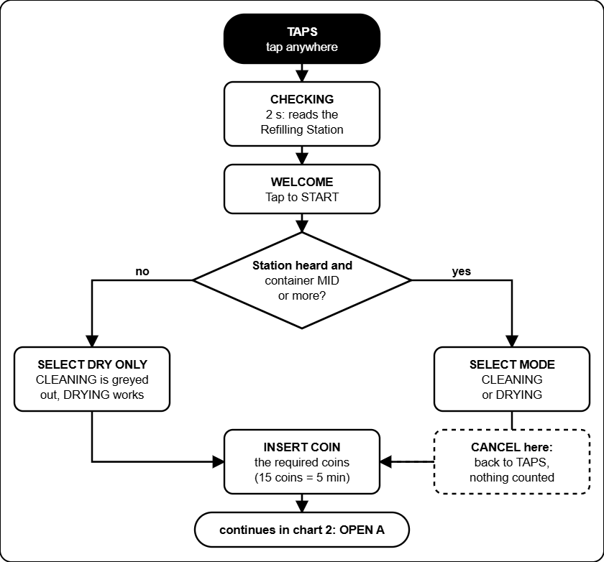
CHECKING reads the Refilling Station, then SELECT MODE. With the station silent or the container EMPTY or LOW only DRYING is offered (SELECT DRY ONLY). The customer pays the required coins.

Chart 2: the run
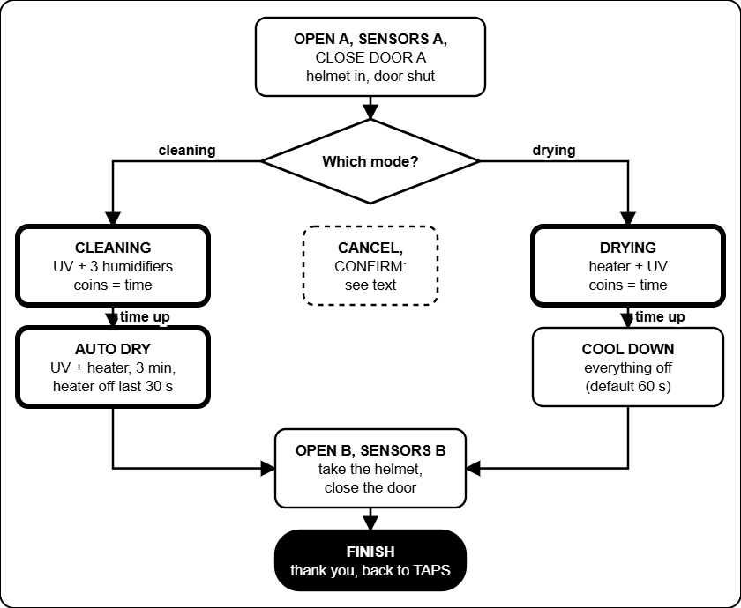
Cleaning (UV-C and mist) then AUTO DRY, or drying (heater and UV-C) then COOL DOWN, then OPEN B and FINISH. CANCEL during a cleaning goes to AUTO DRY, during a drying to COOL DOWN. More coins can be added while it runs.

Troubleshooting decision trees
Start at the black box at the top. Answer each question (the diamonds) with yes or no and follow the arrow. Boxes with a thick border tell you what to do. These trees cover the problems that happen most; the tables in the Admin and Technician guides have the rest.

Symptom | Tree
The screen says OUT OF ORDER | 1. A box shows OUT OF ORDER
A board is OFFLINE in the Devices list | 2. A board shows OFFLINE
A coin goes in and nothing counts | 3. Coin inserted, the count does not move
A helmet is trapped, a door will not open | 4. The door will not open
The Refilling Station does not fill | 5. A container stays EMPTY or LOW
The web page shows old data or no link | 6. The web page says OLD DATA or NO LINK
The touch screen is white, blank or wrong | 7. Screen white, blank or the touch is wrong

Tree 1: a box shows OUT OF ORDER
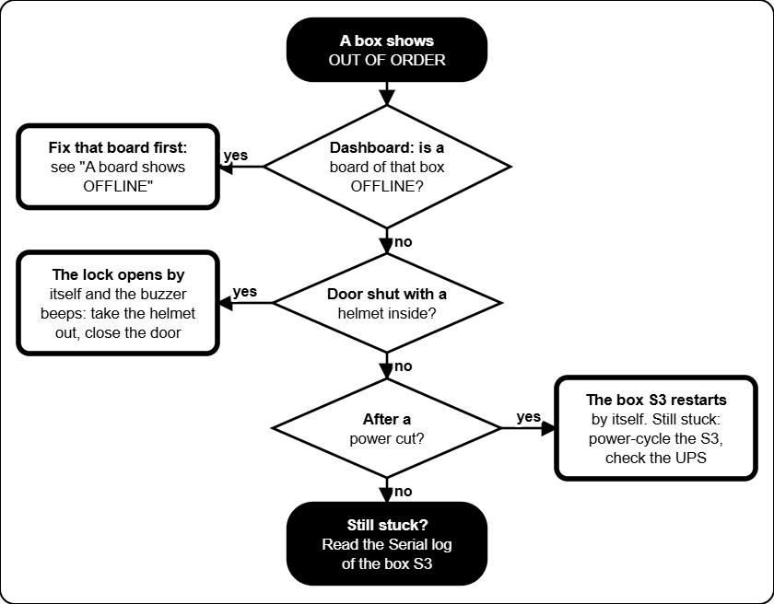
OUT OF ORDER means a board of that box is silent. A helmet that is shut inside is released by itself.

Tree 2: a board shows OFFLINE
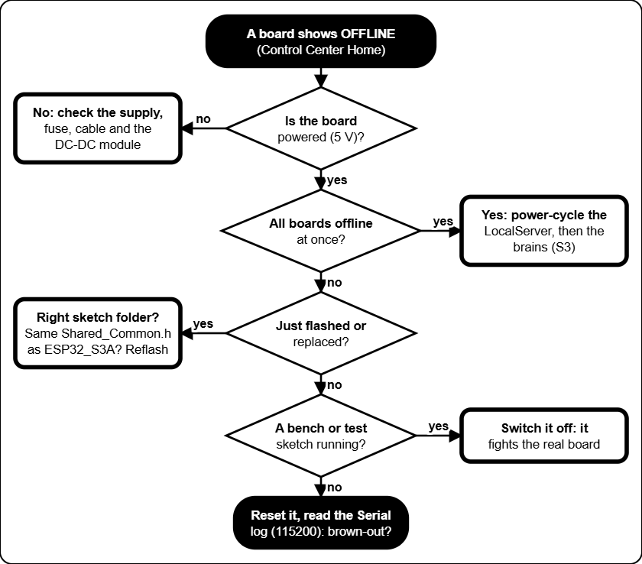
A board is OFFLINE when the LocalServer has heard nothing from it for a while.

Tree 3: coin inserted, nothing counts
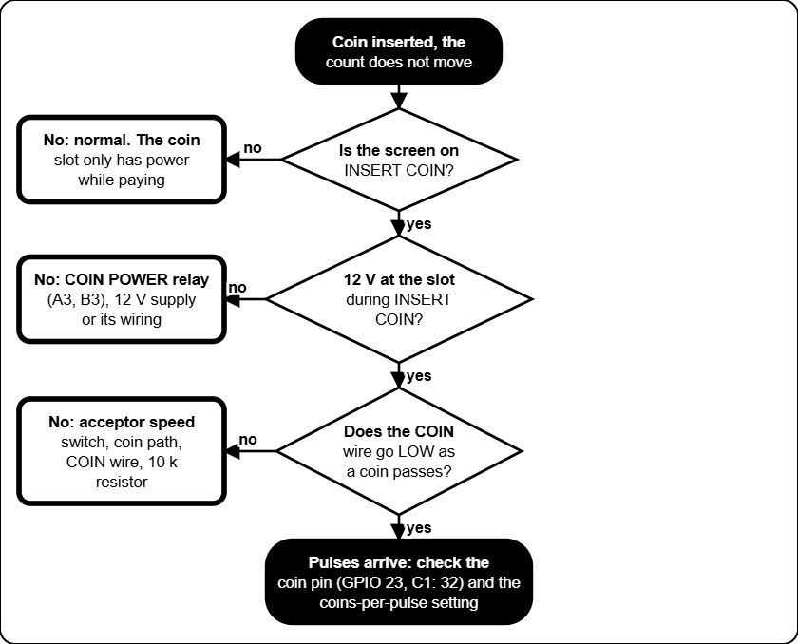
In Box 1 and Box 3 the coin slot has power only while the screen shows INSERT COIN.

Tree 4: the door will not open
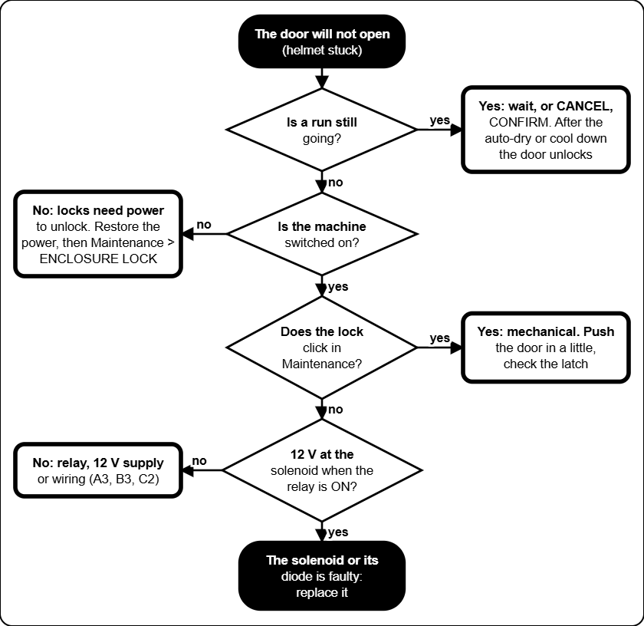
The locks are power-to-unlock: with no power a solenoid door stays shut until the power is back. Switch the mains off before reaching in.

Tree 5: the Refilling Station does not fill
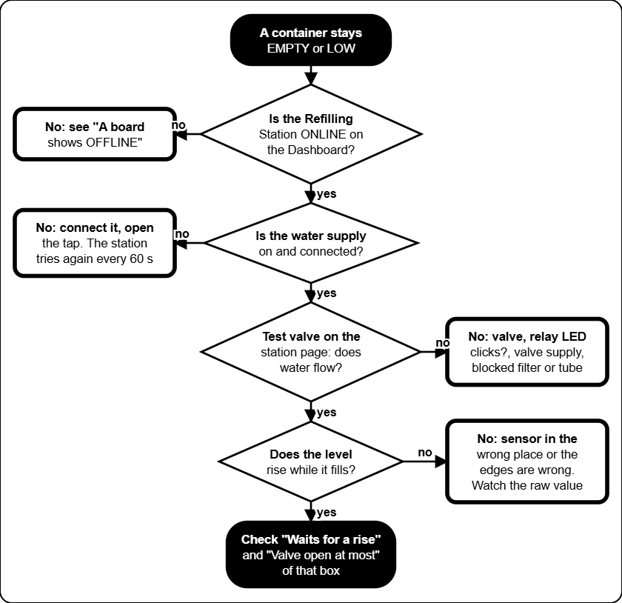
The Refilling Station reads "the level does not rise" as a failed refill: check the supply and the valve.

Tree 6: the web page shows old data
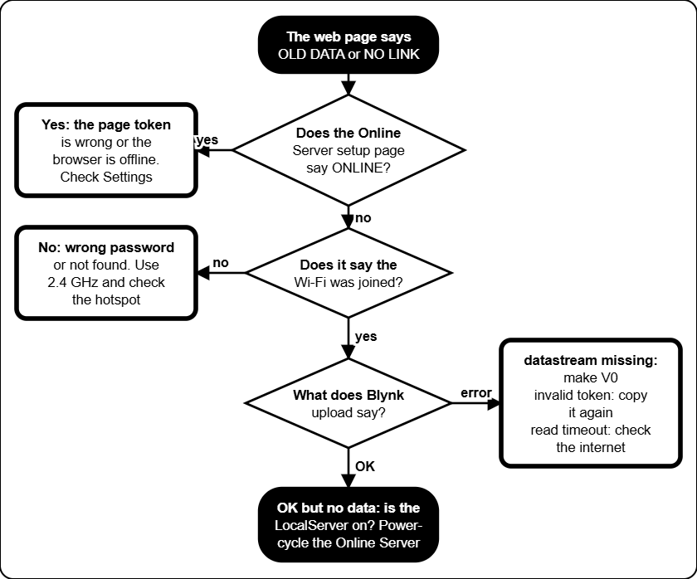
The web page is read only. It shows what the Online Server last sent to Blynk.

Tree 7: the touch screen is white or wrong
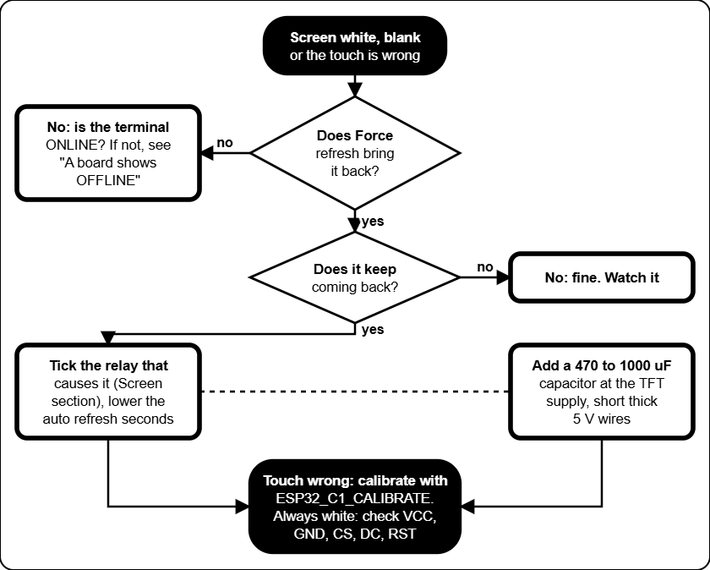
A white screen is almost always a supply dip when a heavy load switches. Force refresh re-initialises the screen.

Settings reference
Every setting you can change, with the value the firmware starts with and the range it accepts (a value outside the range is refused). Write the value you use in the last column. The firmware defaults are what a freshly flashed board starts with; the machine you are looking at may have been changed. Settings are saved inside the boards, so they survive a power cut and a LocalServer swap. Where to change them: Control Center, the box page or the Refilling Station page.

Prices and time (every box)

Setting | What it does | Default | Allowed | Yours
Coin rate | N coins buy X minutes (or seconds). The first N coins are the required coins on INSERT COIN. | 15 coins = 5 min (20 s a coin) | 1-500 coins, 0.1-9999 time
Most coins | Largest number of coins one session can take. | 90 | 1-999
Cool down | How long the cool down lasts after a drying, also after a cancelled drying. | 60 s | 5-900 s
Auto-dry | How long the auto-dry after every cleaning lasts (UV and the heater). | 180 s | 10-900 s
Heater off at the end | How long the heater is off at the end of the auto-dry. | 30 s | 0-900 s
Refilling Station offline after | The station counts as offline when it was not heard for this long: only DRYING is offered. | 15 s | 5-120 s

Sensors (every box)
The helmet sensor is the ultrasonic sensor that looks at the helmet. The container levels are not set on the box page: the Refilling Station reads them (see its table below). The default is a placeholder: measure your real helmet.

Setting | What it does | Default | Allowed | Yours
Helmet counts as inside under | The helmet counts as inside when its sensor reads under this. It also decides when a helmet is trapped during OUT OF ORDER. | 15 cm | 1-200 cm

Screen refresh (all boxes)

Setting | What it does | Default | Allowed | Yours
Refresh when a relay switches on or off | Which relay changes force a full re-initialisation of the touch screen (the white-screen cure). One tick per relay, for ON and for OFF. | Heater on; lock and heater off | Any relay
Auto refresh | Every N seconds the box re-sends the current page as a full re-init. | 2 s | 0 (never) to 60 s

Refilling Station
The Refilling Station keeps the main container of every box topped up from one supply, one valve at a time. The first four numbers and the next five are set per box (the forms on the Refilling Station page); the manual test length is for all boxes. The numbers are raw sensor values (0 when dry, growing as the liquid rises). For now only Box 3 is watched: the settings of Box 1 and Box 2 do nothing until WATCH_BOX is switched on for them.

Setting | What it does | Default | Allowed | Yours
Empty up to (per box) | At or under this raw value the container is EMPTY. | 0 | 0-4095
MID starts (per box) | Where MID starts. Above Empty up to and under this, the level is LOW. | 500 | 1-4095
HIGH starts (per box) | Where HIGH starts. | 1000 | 1-4095
MAX starts (per box) | Where MAX starts. The refill stops here. | 1200 | 1-4095
Waits for a rise when EMPTY | How long the level may stay flat while EMPTY before the refill FAILED. | 30 s | 1-600 s
Waits for a rise when LOW | The same while LOW. | 5 s | 1-600 s
Valve open at most | Longest time one valve may stay open. | 180 s | 10-1800 s
Tries again after | Pause before a failed box tries again (for ever). | 60 s | 5-3600 s
Counts as rising | Smallest step in the raw value that counts as a rise. | 10 | 1-500
Manual test length | How long Test valve opens a valve. | 2 s | 1-30 s

LocalServer and Online Server

Setting | What it does | Default | Allowed | Yours
Control Center Wi-Fi | Name and password of the LocalServer Wi-Fi. Open 192.168.4.1. | JollyHelmet-Local, 12345678 | Set in the firmware
Coin value | Pesos one coin pulse adds to the revenue. | 1.00 | Any positive number
Online Server setup Wi-Fi | Wi-Fi to open the setup page on. | JollyHelmet-Online, 12345678 | Set in the firmware
Send to Blynk every | How often the Online Server uploads. | 1 minute | 30 s, 1, 2 or 5 min
Time zone | Hours from UTC, for the daily revenue. | As set in the portal | -12 to 14
Extra datastreams, events, skip TLS check | V1 to V4, the alert event, and the certificate check. | Off, off, off | On or off
Blynk server | Server name. | blynk.cloud | Text
Public status device token | Token of a second Blynk device for the customer page (status.html). Type - to remove it. | Empty (not used) | A token
Reset statistics | Button in More settings: starts the per-box, busiest-hours and busiest-days counts again from zero. | - | Button
Bypass Safety 2 Seconds Relay | Box page, Maintenance. When ticked, relays you switch on by hand stay on until you switch them off. The heater still stops after 5 minutes and the enclosure lock rests after 60 seconds. | Off (relays go off after 2 s) | Tick or untick
OPEN A / OPEN B beep | Box page. Length of the beep and the wait between beeps while OPEN A or OPEN B waits for the door. Kept in the box. | 100 ms beep, 500 ms wait | Beep 20 to 1000 ms, wait 0 to 10000 ms (0 = one beep)
Date and time (clock) | Settings tab. Set by a phone when the Control Center is opened after a power-on, or typed by hand. A power cut loses it. | Phone's time | Any date and time
Restore from backup CSV | Settings tab. Puts back the sessions of an unchanged Download log (CSV) file. The totals are raised to at least the log's tally. | - | A CSV exactly as downloaded
Previous data (history.json) | Settings tab. Customers from before the log existed, drawn lighter in the chart and counted in the Finished and cancelled card. Never a name. | None | Up to 1000 rows, 64 KB
Crash reports | Settings, This board. The last restarts kept on the board. Delete these reports clears them. | None | The last 3 are kept

Online web page (kept in each browser)

Setting | What it does | Default | Allowed | Yours
Refresh every (Settings window) | How often the page reads Blynk. | 10 s | 5, 10, 30, 60 s
Early warning for containers (Alerts tab) | The dial turns amber and a notice alert starts here. | 30 % | Off, 20-40 %
Play alert sounds, Volume | Master switch and loudness on this device. | On, 80 % | On or off, 0-100 %
Repeat a critical alert every | An unacknowledged critical alert sounds again. | 1 minute | Never, 30 s, 1, 2, 5 min
Sound of each alert | Which sound, or none, each kind of alert plays. | See Alerts and sounds | 9 sounds or silent
Chime when a warning clears | Plays when an alert goes away. | On | On or off
Browser notifications | A notification when the page is in the background. | Off | On or off
publicToken (js/config.js) | Token of the public status device for the customer page. | Empty (the QR address carries it) | A token
prices, contact (js/config.js) | Texts on the customer page. | The firmware prices | Any text

Fixed values (not settings)

Value | Where it comes from
Radio channel 1 | ESP-NOW and the Wi-Fi of the LocalServer must stay on channel 1.
15 s watchdog | No sign of the brain for 15 s: relays off, a trapped helmet is released.
60 s lock, 5 s rest | A lock never stays on longer than that.
5 min heater | Limit of a hand-set heater, in Maintenance.
Coin signal on GPIO 23 | On A1 and B1 (C1 uses GPIO 32).
Box 3 helmet release | OUT OF ORDER with a helmet shut inside: lock released after 2 s, buzzer 100 ms on / 500 ms off, at most 180 s (S3B) or three 60 s windows (B3). Restart check 10 to 18 s after boot.
One valve at a time | The Refilling Station never opens two valves. Valves are closed at power-up and open at most 180 s.
Sensor health | A water-level sensor at 4090 raw or more (3.3 V rail), or jumping by more than 1500 raw within a second while its valve is closed, for 5 s = SENSOR FAULT; it clears after 10 s of normal readings. Not a setting.
Coin counting wait | After the required coins are reached, INSERT COIN waits until no new pulse has been seen for 1.5 s (at most 6 s), so a big coin is counted in full and all of it buys time. Not a setting.

Circuit schematics
The wiring of the machines was drawn in Cirkit Designer. The pictures below are exports of that drawing. Where a picture is missing a dashed box shows the file name to use: save the export in MANUAL\images\cirkit under that name, then rebuild the manual (see the README). The drawings in the Technician guide (power, relay stage, locks, coin slot, Online Server) are a simplified view of the same wiring.

Picture | Shows | File name
Whole installation | All boards and how they are powered | cirkit_overview
Box 1 | A1, A2, A3, S3A | cirkit_box1
Box 2 | C1, C2, S3C | cirkit_box2
Box 3 | B1, B2, B3, S3B | cirkit_box3
Refill station | Refilling Station: sensors, valves and relay module (drawn for this manual) | (drawn for this manual)

The Cirkit drawing was checked against what was really built. Where the two differ, the pinout tables in the Technician guide are right (they come from the flashed firmware). Relay input numbers (IN1 ...) come from the drawing.

Whole installation

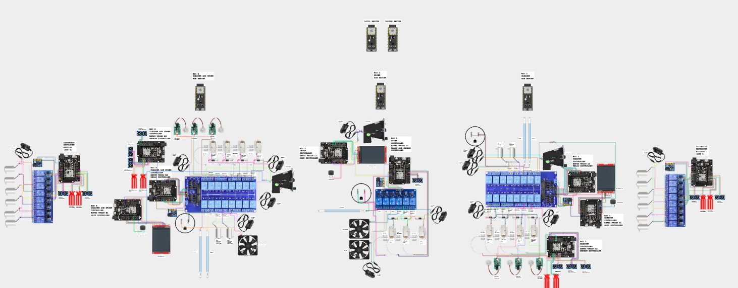
Cirkit Designer picture goes here
Delete this text and use Insert, Pictures. (For the PDF the picture is saved as images\cirkit\cirkit_overview.png.)
Whole installation (Cirkit Designer)

Box 1: A1, A2, A3

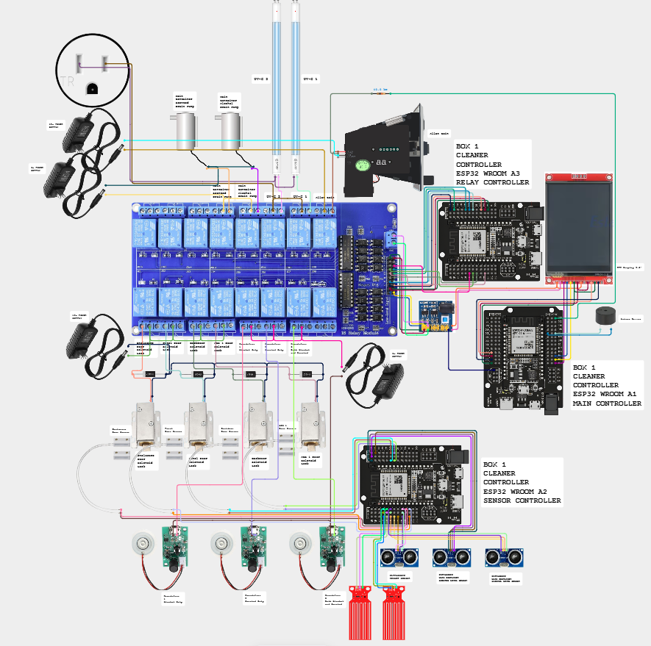

Box 1 (Cirkit Designer)

Box 2: C1, C2

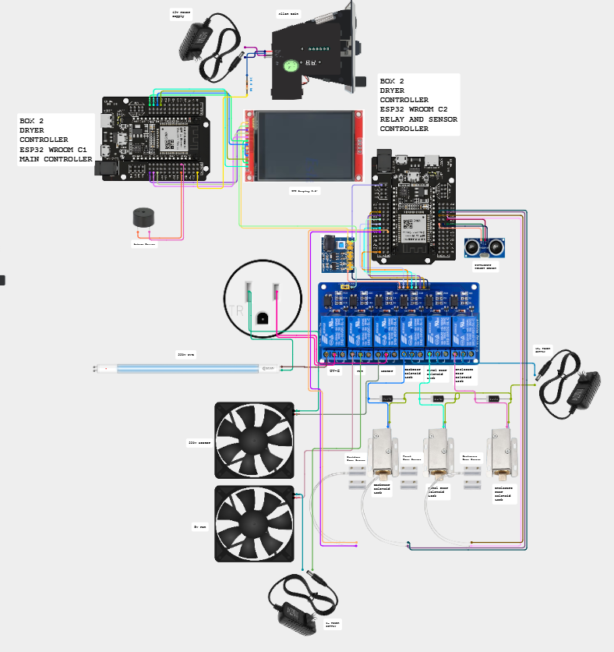

Box 2 (Cirkit Designer)

Box 3: B1, B2, B3

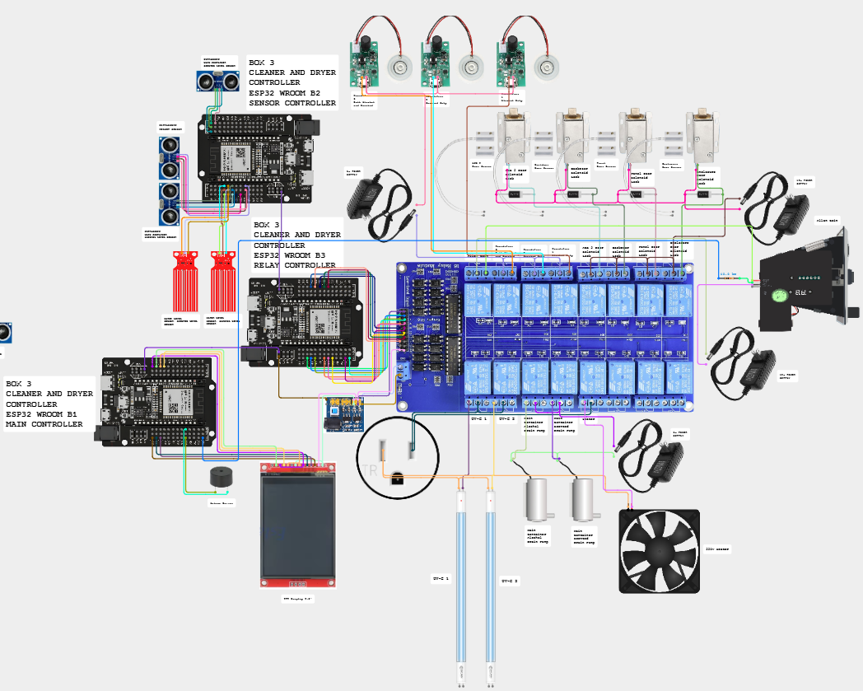

Box 3 (Cirkit Designer)

Refilling Station
The wiring of the Refilling Station was drawn for this manual from ESP32_REFILL.ino and the pin sheet; there is no Cirkit Designer export of it.
Refilling Station: sensors, relay module and valves

Glossary
Words used in this manual, in plain language.

Term | Meaning
2-second safety | In Maintenance a relay you switch on by hand switches itself off after 2 seconds, done by the box itself. The coin power is exempt. See Bypass Safety 2 Seconds Relay.
Acknowledge | The button on the online page that stops a repeating alarm. A new alert still sounds.
ACS | Auto Container System. The two refill boards used before 2026-11-03; the Refilling Station replaced them.
Alert sound | The beep pattern of one kind of alert (siren, alarm, three beeps, two tones, chime...). Each can be changed in the Alerts tab.
Allan coin acceptor | The coin slot. It sends one pulse for each coin value it accepts.
Auto dry | The drying that ends every cleaning: UV light and the heater for 3 minutes by default, the heater off for the last 30 seconds.
Backup log (CSV) | The file that Download log (CSV) gives you: every session the machines recorded, with date, time, box, coins and minutes. Keep copies: Restore from backup CSV reads it.
Blynk | The online service the Online Server sends its snapshot to. The web page reads it from there.
Brain | The ESP32-S3 board of a box (S3A, S3B, S3C). It runs every step and keeps the settings. A box has one brain and several terminals.
Bypass Safety 2 Seconds Relay | The Maintenance tick box that turns the 2-second safety off, so hand-set relays stay on until you switch them off.
Captive portal | The page that opens by itself when a phone joins the setup Wi-Fi of the Online Server.
Channel 1 | The radio channel all the boards use for ESP-NOW. The LocalServer Wi-Fi stays on it too.
CHECKING | The 2-second "Checking Main Container" screen after the first tap: the box reads the Refilling Station.
Control Center | The pages of the LocalServer (Dashboard, Settings, Box 1, Box 2, Box 3, Refilling Station) where settings, calibration and Maintenance are done.
Cool down | The time after drying when nothing heats and the helmet can cool (60 seconds by default). Box 2 also runs its fan.
Crash report | A note the LocalServer keeps in its own flash after a restart it did not plan (the last three are kept). Read it in Settings, This board, and send a screenshot to the developer.
Customer status page | status.html: the public page that shows which machine is free, in use or out of order.
Dashboard | The first tab of the Control Center (called Home in older pages): the three boxes, the Refilling Station, the statistics and the Devices line.
Datastream | A named value in Blynk. This project uses V0 (a text) and, if you switch them on, V1 to V4.
Day viewer | The card that opens when you tap a bar of the Daily chart or pick a date: the customers of that day, with a Machine tab and a JSON tab.
DC-DC module | The power module that turns 12 V into 5 V and 3.3 V for the boards, sensors and small loads.
Devices line | The line on the Dashboard that says how many boards answer (for example 12 of 12 online). Tap it for the badge of every board.
Early warning | The level (30 % by default) where a container dial turns amber and a notice appears, before the box runs out.
Enclosure lock | The solenoid lock of the main door of a box. It is the one released for a trapped helmet.
ESP-NOW | The radio link the boards talk over. No router is needed.
ESP32 and ESP32-S3 | The two kinds of board. The plain ESP32 boards are terminals. The S3 boards are brains and servers.
GPIO | A numbered pin of an ESP32 board.
history.json (previous data) | The file of customers the team collected from its own records before the log existed. The chart draws it lighter and the Finished and cancelled card counts it, but it never changes the machine log, the totals or the CSV.
Humidifier | The ultrasonic mist maker (5 V). Three of them make the mist during CLEANING.
Integrity line | The last line of the backup CSV. It lets the LocalServer refuse a file that was edited or saved again. It protects against mistakes; it is not a lock.
JD-VCC | The separate power input of a relay module's coils, with a jumper to the logic supply.
Level (EMPTY, LOW, MID, HIGH, MAX) | How full a main container is, worked out by the Refilling Station from its water-level sensor and the four edges set for that box.
Level dial | The half-circle gauge of a container on the Monitor tab. Red = EMPTY or LOW, green = MAX.
LocalServer | The board that makes the JollyHelmet-Local Wi-Fi and the Control Center, and counts the revenue.
Main controller | The plain name of a box's brain (S3A, S3B, S3C).
Maintenance mode | A page where a technician switches relays by hand. The machine shows MAINTENANCE. Hand-set relays go off after 2 seconds unless the safety is bypassed.
Mist | The fine vapour of the cleaning liquid that the humidifiers make during CLEANING.
Navigation bar | The row at the top of every Control Center page: Dashboard, Settings, Box 1, Box 2, Box 3, Refilling Station.
Nickname | The optional name of up to 12 characters a customer can type on the status page while the cycle runs. It is public and clears when the cycle ends.
NOT WATCHED | What the Refilling Station reports for a box it does not serve (Box 1 and Box 2 for now): no level, no refill, no warning. Set by WATCH_BOX in the station's sketch.
NVS | The memory inside a board where settings are saved (they survive a power cut).
Online Server | The ESP32-S3 that listens to the machines and sends a snapshot to Blynk. It never controls anything.
OUT OF ORDER | The screen shown when a box cannot serve customers.
Power-to-unlock | A lock that opens only while it has power. With no power the door stays locked.
Public status device | The second Blynk device whose token may be public. It holds only the step and time left of each box.
QR code | The square code on the sign at each machine. A phone camera opens the customer status page with it.
Queue | The containers waiting for the Refilling Station's valve: EMPTY first, then LOW, first come first served.
Refilling Station | The one board with three water-level sensors and three valves that keeps the main containers full. For now it watches and refills Box 3 only. It replaced ACS 1 and ACS 2.
Relay | An electrically operated switch. The boards use relays to switch locks, mist makers, lamps and the heater.
Required coins | The number of coins INSERT COIN asks for: one step of the coin rate (15 coins in the default).
SAFETY PAUSE | The screen shown when a door opens during a run. The loads switch off until the door is closed.
SELECT DRY ONLY | The mode screen with CLEANING greyed out: the liquid is low or the Refilling Station is not answering.
SENSOR FAULT | What the Refilling Station reports for a container whose water-level sensor reads on the 3.3 V rail or jumps about wildly. The box offers drying only until the reading is normal for 10 seconds.
Serial Monitor | The Arduino IDE window that shows what a board prints over USB (115200 baud).
SoftAP | A Wi-Fi network made by a board itself (JollyHelmet-Local, JollyHelmet-Online).
Terminal | A plain ESP32 board that holds a box's sensors, relays and display. It follows its brain.
TFT | The 2.8 inch colour touch screen of a box.
Token | The secret key that lets the Online Server write to your Blynk template. Keep it private.
Ultrasonic sensor | The HC-SR04. It measures the distance to the helmet or to the liquid in a container.
UPS | A battery backup. In Box 3 it keeps the screen, sensor and relay boards alive during a power cut, so the helmet can be released.
UV-C lamp | The 220 V germicidal lamp. Never look at it when it is lit.
Valve | The normally closed solenoid valve that lets water into one main container when the Refilling Station opens it.
Watchdog | A safety check: if a board stops hearing its brain for 15 seconds it switches its loads off.

Version and revisions

Item | Value
Manual | Jolly Helmet User Manual, revision 11, 2026-11-04
Made by | MEJEZ STUDIO
Covers | Box 1, Box 2, Box 3, Refilling Station, LocalServer, Online Server
Protocol file | Shared_Common.h, identical in every sketch folder (checksum 16217b04)

Revision history

Rev | Date | What changed
1 | 2026-10-07 | First manual: customer guide and admin guide for Box 1, 2 and 3, prices, Control Center, ACS. PDF and Word, new logo, Arial.
2 | 2026-10-07 | Technician guide: components, pinouts, circuit and wiring, firmware and flashing, maintenance, hardware troubleshooting. Corrected from the Cirkit Designer document to what was really built.
3 | 2026-10-10 | Online Server, Blynk setup and the web page. Real parts: UV-C 220 V lamps, HC-SR04, 5 V mist makers and pumps, DC-DC module. Team names on the cover.
4 | 2026-10-10 | Reference section: safety and emergencies, box flowcharts, troubleshooting decision trees, settings reference, schematic pages, policies, glossary, this page and the index.
5 | 2026-10-11 | Online page: level dials with early warning, Alerts with a sound for every kind of alert, Reports (busiest hours and days, what each box earns), Checklist, Fix it, customer status page and QR sign, Manual tab with a team password. New Online Server firmware (per-box statistics, public status device).
6 | 2026-10-11 | The safety slide of the enclosure door (lower left, slide down to unlock by hand when the solenoid lock is broken or there is no power): customer guide, admin guide, technician guide, safety and emergencies, decision tree 4, settings reference, glossary and policies.
7 | 2026-10-11 | Box flowcharts and troubleshooting decision trees redrawn in black and white (no colours): thick border = the machine is running or "do this", double border = a fault, black box = start or end.
8 | 2026-10-16 | The LocalServer Wi-Fi is now called JollyHelmet-Local (it was ESP32_LOCAL; the password and the address 192.168.4.1 are unchanged). Updated in the join steps, the settings reference, the glossary and the index. Phones that saved the old name must join the new one; the spare ENTRY board must be flashed with the matching name.
9 | 2026-10-16 | One navigation bar and a Devices line instead of the menu button; the Dashboard, the day viewer (Machine and JSON tabs), the combined Finished and cancelled tally, the Settings tab with the backup restore, the previous-data label and the crash reports kept on the board. Maintenance 2-second safety with its bypass and the drain pump warning; the OPEN A / OPEN B beep settings. The ENTRY board (coins and minutes both ways, captive portal). C1 coin signal moved to GPIO 32. Optional customer names on the status page. Firmware dates and all Control Center screenshots renewed.
10 | 2026-11-04 | The Refilling Station (3 water-level sensors, 3 valves, one valve at a time) replaces ACS 1 and ACS 2: new chapter, wiring, pinout, settings, charts and decision tree 5. Box 3 runs the trimmed 36-step flow (CHECKING, SELECT MODE or SELECT DRY ONLY, required coins, auto-dry, cancel paths, no ratings): customer pictures, charts 5 and 6, prices, settings page. OUT OF ORDER never traps a helmet; UPS design; restart check; one helmet cut-off for S3B, B3 and B1. 14 boards, 12 devices on the Dashboard. The online page chapter no longer mentions the removed Checklist, Fix it and Manual tabs. Box 1 and Box 2 are unchanged (earlier program). Sensor check of the Refilling Station (SENSOR FAULT) added.
11 | 2026-11-04 | Everything that no longer exists was taken out: ratings, the time picker, the mist choice and the free retry; the safety slide of the enclosure door; the ENTRY board; the pumps and the drain pump warning. Box 1, Box 2 and Box 3 are written as one Cleaner + Dryer (two charts, one price list, one box page). New pictures of the Control Center, Maintenance, the Online Server setup page (Network Map) and the web page; the drawings, chart 1 and decision tree 4 were redrawn. Box 1 and Box 2 still run their earlier program and their Control Center pages are not rebuilt yet. The Refilling Station watches and refills Box 3 only for now; Box 1 and Box 2 show NOT WATCHED. INSERT COIN now waits for the coin acceptor to finish counting, so a bigger coin than asked adds time.

Firmware in this manual
The date is when the sketch file was last saved. The board in the machine may carry an older build: compare with what it prints when it starts (Serial Monitor, 115200). Box 1 and Box 2 (S3A, S3C and their terminals) still run their earlier program. They are rebuilt to the Box 3 flow next; the customer, admin and reference parts of this manual already describe that flow. When they run the Box 3 flow, switch them on in WATCH_BOX (ESP32_REFILL.ino), otherwise they would offer DRYING only.

Sketch folder | Board | Role | File date
ESP32_S3A | S3A | Box 1 brain | 2026-10-15
ESP32_A1 | A1 | Box 1 screen, coin, buzzer | 2026-10-13
ESP32_A2 | A2 | Box 1 sensors | 2026-10-13
ESP32_A3 | A3 | Box 1 relays | 2026-10-13
ESP32_S3C | S3C | Box 2 brain | 2026-10-15
ESP32_C1 | C1 | Box 2 screen, coin, buzzer | 2026-10-15
ESP32_C2 | C2 | Box 2 sensors and relays | 2026-10-13
ESP32_S3B | S3B | Box 3 brain | 2026-11-04
ESP32_B1 | B1 | Box 3 screen, coin, buzzer | 2026-11-03
ESP32_B2 | B2 | Box 3 sensors | 2026-11-03
ESP32_B3 | B3 | Box 3 relays | 2026-11-03
ESP32_REFILL | Refilling Station | Boxes 1 to 3 containers: sensors and valves | 2026-11-04
ESP32_LOCALSRV | LocalServer | Control Center, revenue | 2026-11-04
ESP32_ONLINESRV | Online Server | Blynk monitor | 2026-11-04
ESP32_REFILL_FAKE | Test tool | Stand-in for the Refilling Station on a spare ESP32 (own Wi-Fi page) | 2026-11-04

Tools and libraries

Item | Version
Arduino IDE board package: esp32 by Espressif | 3.3.7
TFT_eSPI | 2.5.43
ArduinoJson | 7.4.3
ESP_Async_WebServer | 3.12.0
Async_TCP | 3.5.0
Blynk | Blynk Cloud HTTPS API (no library on the board)

Check before you hand over
- Refilling Station: measure the raw value of each sensor dry and in the liquid, set the four edges of every box, connect the supply, then test each valve by hand (Test valve) before the first automatic refill. For now only Box 3 is watched (WATCH_BOX), so do this for Box 3 first.
- Run every relay by hand in Maintenance before the first automatic run.
- Box 3: set Helmet counts as inside under (use live). Then unplug S3B with a helmet inside and the door shut: after about 15 seconds the lock must release and the screen board must beep. Plug S3B in again: about 12 seconds after it is back it must hand the helmet back (OPEN B).
- Calibrate the touch screen of B1 (it still has the A1 numbers) with ESP32_C1_CALIBRATE.
- Online Server: after its first upload, the Control Center must still hear every board (12 of 12). If it does not, check the radio channel.
- Online page: flash the Online Server firmware of 2026-10-10, create the public status Blynk device, print the QR sign for every machine, and run build_web_manual.ps1 after every change to this manual.

Index
Page numbers refer to this manual. In the Word file, right-click the index and choose Update field to refresh it after editing.

12 V power supply, 10, 11, 31
1N4007 diode, 10, 31
220 V mains, 9, 10, 12, 13
A1 (Box 1 screen board), 9, 20, 31, 52
A2 (Box 1 sensor board), 21, 31, 52
A3 (Box 1 relay board), 9, 11, 13, 21, 31, 32, 52
Alerts and alert sounds, 29, 51
Allan coin acceptor (coin slot), 9, 10, 11, 12
Arduino IDE, 20
Auto dry, 39
B1 (Box 3 screen board), 9, 19, 20, 30, 31, 52
B2 (Box 3 sensor board), 31, 52
B3 (Box 3 relay board), 9, 11, 21, 31, 32, 52
Blynk, 7, 22, 24
Board settings (flashing), 11, 20, 23, 31
Buzzer, 9, 11, 18, 21
C1 (Box 2 screen board), 9, 20, 31, 52
C2 (Box 2 relay and sensor board), 9, 13, 31, 32, 52
Calibration, 21, 30
Captive portal, 49
Cirkit Designer, 11, 52
Coin value and revenue, 7, 21, 22, 23, 27
Control Center, 20, 30, 32
Cool down, 10, 34, 35, 37, 48
Customer names (nickname), 28
Customer status page, 27
DC-DC module, 10, 15, 31
Door lock (solenoid), 7, 8, 9, 10, 12, 13, 15, 17, 21, 26
Door sensor (MC-38), 9, 12, 13, 18
ESP-NOW and channel 1, 6, 20, 26, 27, 32, 51
Fan, 10, 30
Fuse, 10, 15, 17, 30, 31, 32, 35
Heater, 7, 10, 13, 15
Humidifier (mist maker), 9, 12, 15, 30
Level dials (early warning), 51
LocalServer, 7, 9, 15, 20
Maintenance mode, 30
Network map (setup page), 23, 26
Online page, 27, 64
Online Server, 7, 9, 20, 21, 22, 26
OUT OF ORDER, 30, 34, 40, 48
Pinouts, 52
Power cut (power-to-unlock), 17, 32, 34, 44, 48
Public status device, 27, 28, 29
QR code, 27
Refilling Station, 6, 7, 37, 48, 56
Reports tab (busiest hours, box earnings), 28, 29
Required coins, 18, 38
S3A (Box 1 brain), 7, 9, 20, 21, 52
S3B (Box 3 brain), 7, 9, 20, 52
S3C (Box 2 brain), 7, 9, 20, 52
SAFETY PAUSE, 21, 30, 34, 35
Screen refresh (white screen), 15, 32
SELECT DRY ONLY, 38
Serial Monitor, 20
Token (Blynk), 7, 22, 24, 25, 26, 31
Touch screen (TFT), 9, 11, 15, 19
Trapped helmet, 7, 17, 32, 34, 40, 51
Ultrasonic sensor (HC-SR04), 9, 11, 12, 13
UPS, 7, 34
UV-C lamp, 9, 10, 12, 13, 15, 17
V0 datastream, 22, 26, 27, 50
Valve, 13, 14
Watchdog (15 seconds), 35, 51
Water-level sensor, 9, 12, 15
Web page (monitor), 22, 23, 40
Wi-Fi JollyHelmet-Local, 49

Thank you for using
Jolly Helmet
We hope to see you again!
Make your Helmet Happy Again.
MEJES, JERAHMEEL ALZEL M.
CRUZ, DEAN RYAN P.
MENDOZA, RICAH S.
MARTOS, KRISTINA E.
DEVELOPERS AND DESIGNERS
USER MANUAL - TECHNICIAN GUIDE

